Lab Report

For

Computer Graphics

Implementation Using Java

**Submitted By: Submitted To:**

Shahil Jha Mr. Manoj Giri

5th Semester, BIM Computer Graphics Instructor

Acknowledgement

This report has been written in order to fulfill the partial requirement of Tribhuvan University (TU) for the completion of the 5th semester of Bachelor of Information Management (BIM). Although this is an individual project assigned during the academic study in BIM Fifth Semester, I remain thankful to many people for the successful completion of this report.

First of all, I would like to thank my respected Computer Graphics Instructor, Manoj Giri, for his persistence in providing guidance throughout this academic study until its completion. His suggestions and guidance in every stage was a major factor in the completion of this report. Without his proper guidance, this report would not have been completed.

I am also thankful to my friends for providing aid when in confusion in the process of this report throughout this report.

At last, I would like to extend my thanks to our respected principle, Dr. Anil Lal Amatya for helping and encouraging in every aspect of our academic study and much appreciation to Asian School of Management and Technology, Kathmandu, Nepal.

Contents

1. Translation 1

2. Scaling 3

a. About Origin 3

b. About an Arbitrary Point 6

3. Rotation 9

a. About Origin 9

b. About an Arbitrary Point 11

4. Reflection 14

a. About X-Axis 14

b. About Y-Axis 18

c. About Y=X 21

d. About Y=-X 24

e. About Origin 27

f. About an Arbitrary Line 30

5. Shear 33

a. In X Direction 33

b. In Y Direction 36

c. In XY Direction 39

6. Drawing Lines 41

7. Drawing Strings 42

8. Bresenham's Line Algorithm(BLA) 44

9. Digital Differential Analyzer (DDA) Algorithm 46

10. General Circle Drawing Algorithm 47

a. About Origin 47

b. At an Arbitrary Point 49

11. Mid-Point Circle Drawing Algorithm 51

a. About Origin 51

b. About an Arbitrary Point 53

12. Boundary Fill Algorithm 55

13. Flood Fill Algorithm 57

# Translation

* Shahil_Translation.java

**import** javax.swing.JFrame;

**public** **class** Shahil_Translation{

**static** **int** *arr*[][] = {{100, 100},{150, 200}};

**static** **int**[][] *result* = **new** **int**[2][2];

**static** **int**[] *translate_factor* = {200, 100};

**final** **static** **int** ***DEFAULT_HEIGHT*** = 800;

**final** **static** **int** ***DEFAULT_WIDTH*** = 800;

**final** **static** **int** ***DEFAULT_X_MID*** = ***DEFAULT_HEIGHT***/2;

**final** **static** **int** ***DEFAULT_Y_MID*** = ***DEFAULT_WIDTH***/2;

**public** **static** JFrame *frame*;

**public** Shahil_Translation() {

//Frame making

*frame* = **new** JFrame();

*frame*.setTitle("Translation");

*frame*.setSize(***DEFAULT_WIDTH***,***DEFAULT_HEIGHT***);

*frame*.setVisible(**true**);

*frame*.setDefaultCloseOperation(JFrame.***EXIT_ON_CLOSE***);

}

**public** **void** Shahil_drawQuartine(){

//Drawing of axes

*frame*.add(**new** Shahil_Translation_drawComponent(***DEFAULT_HEIGHT***, ***DEFAULT_WIDTH***, *arr*, *result*));

}

**public** **void** Shahil_Opertaion() {

**for**(**int** i = 0 ; i<2; i++) {

*result*[i][0] = *arr*[i][0] + *translate_factor*[0];

*result*[i][1] = *arr*[i][1] + *translate_factor*[1];

}

}

**public** **static** **void** main(String[] args) {

Shahil_Translation Shahil_obj = **new** Shahil_Translation();

Shahil_obj.Shahil_Opertaion();

Shahil_obj.Shahil_drawQuartine();

}

}

* Shahil_Translation_drawComponent.java

**import** java.awt.Color;

**import** java.awt.Graphics;

**import** java.awt.Graphics2D;

**import** java.awt.geom.Line2D;

**import** java.awt.geom.Point2D;

**import** javax.swing.JComponent;

**public** **class** Shahil_Translation_drawComponent **extends** JComponent{

**static** **int** *DEFAULT_HEIGHT*;

**static** **int** *DEFAULT_WIDTH*;

**static** **int** *DEFAULT_HEIGHT_MID*;

**static** **int** *DEFAULT_WIDTH_MID*;

**static** **int** *arr*[][];

**static** **int** *result*[][];

**static** **int** *x1*,*y1*,*x2*,*y2*;

**static** **int** *a1*,*b1*,*a2*,*b2*;

Shahil_Translation_drawComponent(**int** DEFAULT_HEIGHT, **int** DEFAULT_WIDTH, **int**[][] arr, **int**[][] result){

**this**.*DEFAULT_HEIGHT* = DEFAULT_HEIGHT;

**this**.*DEFAULT_WIDTH* = DEFAULT_WIDTH;

*DEFAULT_HEIGHT_MID* = DEFAULT_HEIGHT/2;

*DEFAULT_WIDTH_MID* = DEFAULT_WIDTH/2;

**this**.*arr* = arr;

**this**.*result* = result;

*Shahil_mapArray*();

}

**public** **static** **void** Shahil_mapArray() {

*x1* = *arr*[0][0];

*y1* = *arr*[0][1];

*x2* = *arr* [1][0];

*y2* = *arr*[1][1];

*a1* = *result*[0][0];

*b1* = *result*[0][1];

*a2* = *result* [1][0];

*b2* = *result*[1][1];

}

**public** **void** paintComponent(Graphics g){

Graphics2D g2d = (Graphics2D) g;

//Making the x and y axes

Line2D.Double x_line = **new** Line2D.Double(**new** Point2D.Double(0,*DEFAULT_HEIGHT_MID*), **new** Point2D.Double(*DEFAULT_WIDTH*,*DEFAULT_HEIGHT_MID*));

Line2D.Double y_line = **new** Line2D.Double(**new** Point2D.Double(*DEFAULT_WIDTH_MID*, 0), **new** Point2D.Double(*DEFAULT_WIDTH_MID*, *DEFAULT_HEIGHT*));

g2d.draw(x_line);

g2d.draw(y_line);

g2d.rotate(Math.*toRadians*(-90),400,400);

g2d.translate(400, 400);

Line2D.Double Line1 = **new** Line2D.Double(**new** Point2D.Double(*x1*, *y1*), **new** Point2D.Double(*x2*,*y2*));

g2d.draw(Line1);

g2d.setColor(Color.***RED***);

Line2D.Double Line2 = **new** Line2D.Double(**new** Point2D.Double(*a1*,*b1*), **new** Point2D.Double(*a2*,*b2*));

g2d.draw(Line2);

}

}

* Output

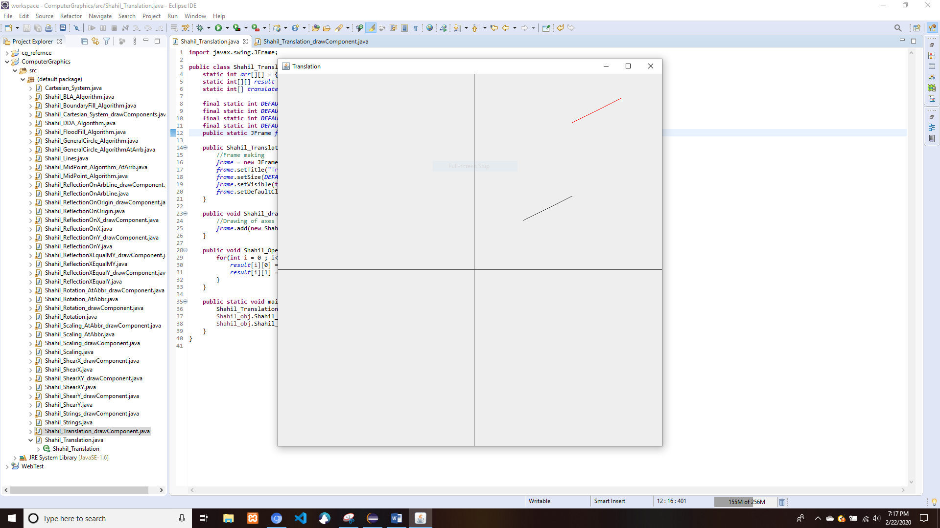

# Scaling

## About Origin

* Shahil_Scaling.java

**import** javax.swing.JFrame;

**public** **class** Shahil_Scaling {

**static** **int** *arr_x*[] = {123,100,156};

**static** **int** *arr_y*[] = {90,167,78};

**static** **int**[] *res_x* = **new** **int**[3];

**static** **int**[] *res_y* = **new** **int**[3];

**static** **int**[] *scaling_factor* = {2, 2};

**final** **static** **int** ***DEFAULT_HEIGHT*** = 800;

**final** **static** **int** ***DEFAULT_WIDTH*** = 800;

**final** **static** **int** ***DEFAULT_X_MID*** = ***DEFAULT_HEIGHT***/2;

**final** **static** **int** ***DEFAULT_Y_MID*** = ***DEFAULT_WIDTH***/2;

**public** **static** JFrame *frame*;

**public** Shahil_Scaling() {

//Frame making

*frame* = **new** JFrame();

*frame*.setTitle("Scaling");

*frame*.setSize(***DEFAULT_WIDTH***,***DEFAULT_HEIGHT***);

*frame*.setVisible(**true**);

*frame*.setDefaultCloseOperation(JFrame.***EXIT_ON_CLOSE***);

}

**public** **void** Shahil_drawQuartine(){

//Drawing of axes

*frame*.add(**new** Shahil_Scaling_drawComponent(***DEFAULT_HEIGHT***, ***DEFAULT_WIDTH***, *arr_x*, *arr_y* , *res_x*, *res_y*));

}

**public** **void** Shahil_Opertaion() {

**for**(**int** i = 0 ; i<3; i++) {

*res_x*[i] = *arr_x*[i] * *scaling_factor*[0];

*res_y*[i] = *arr_y*[i] * *scaling_factor*[1];

System.***out***.println(*res_x*[i]+"\t"+*res_y*[i]);

}

}

**public** **static** **void** main(String[] args) {

Shahil_Scaling Shahil_obj = **new** Shahil_Scaling();

Shahil_obj.Shahil_Opertaion();

Shahil_obj.Shahil_drawQuartine();

}

}

* Shahil_Scaling_drawComponent.java

**import** java.awt.Color;

**import** java.awt.Graphics;

**import** java.awt.Graphics2D;

**import** java.awt.Polygon;

**import** java.awt.Rectangle;

**import** java.awt.geom.Line2D;

**import** java.awt.geom.Point2D;

**import** javax.swing.JComponent;

**public** **class** Shahil_Scaling_drawComponent **extends** JComponent{

**static** **int** *DEFAULT_HEIGHT*;

**static** **int** *DEFAULT_WIDTH*;

**static** **int** *DEFAULT_HEIGHT_MID*;

**static** **int** *DEFAULT_WIDTH_MID*;

**static** **int** *arr_x*[];

**static** **int** *arr_y*[];

**static** **int** *res_x*[];

**static** **int** *res_y*[];

**static** **int** *x1*, *x2*, *x3*;

**static** **int** *y1*, *y2*, *y3*;

Shahil_Scaling_drawComponent(**int** DEFAULT_HEIGHT, **int** DEFAULT_WIDTH, **int**[] arr_x, **int**[] arr_y, **int**[] res_x, **int**[] res_y){

**this**.*DEFAULT_HEIGHT* = DEFAULT_HEIGHT;

**this**.*DEFAULT_WIDTH* = DEFAULT_WIDTH;

*DEFAULT_HEIGHT_MID* = DEFAULT_HEIGHT/2;

*DEFAULT_WIDTH_MID* = DEFAULT_WIDTH/2;

**this**.*arr_x* = arr_x;

**this**.*arr_y* = arr_y;

**this**.*res_x* = res_x;

**this**.*res_y* = res_y;

}

**public** **void** paintComponent(Graphics g){

Graphics2D g2d = (Graphics2D) g;

//Making the x and y axes

Line2D.Double x_line = **new** Line2D.Double(**new** Point2D.Double(0,*DEFAULT_HEIGHT_MID*), **new** Point2D.Double(*DEFAULT_WIDTH*,*DEFAULT_HEIGHT_MID*));

Line2D.Double y_line = **new** Line2D.Double(**new** Point2D.Double(*DEFAULT_WIDTH_MID*, 0), **new** Point2D.Double(*DEFAULT_WIDTH_MID*, *DEFAULT_HEIGHT*));

g2d.draw(x_line);

g2d.draw(y_line);

g2d.rotate(Math.*toRadians*(-90),400,400);

g2d.translate(400, 400);

g2d.drawPolygon(*arr_x*, *arr_y*, *arr_x*.length);

g2d.drawPolygon(*res_x*, *res_y*, *res_x*.length);

}

}

* Output

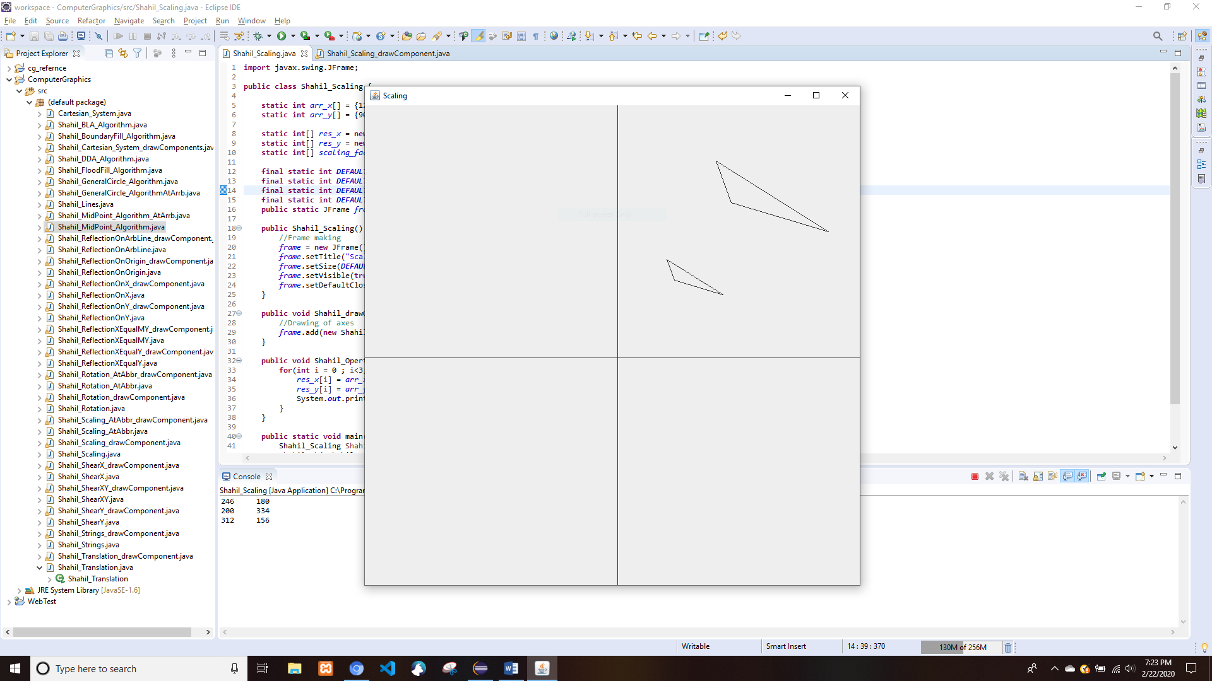

## About an Arbitrary Point

* Shahil_Scaling_AtAbbr.java

**import** javax.swing.JFrame;

**public** **class** Shahil_Scaling_AtAbbr {

**static** **int** *arr_x*[] = {123,100,156};

**static** **int** *arr_y*[] = {90,167,78};

**static** **int**[] *res_x* = **new** **int**[3];

**static** **int**[] *res_y* = **new** **int**[3];

**static** **int**[] *scaling_factor* = {2, 2};

**final** **static** **int** ***DEFAULT_HEIGHT*** = 800;

**final** **static** **int** ***DEFAULT_WIDTH*** = 800;

**final** **static** **int** ***DEFAULT_X_MID*** = ***DEFAULT_HEIGHT***/2;

**final** **static** **int** ***DEFAULT_Y_MID*** = ***DEFAULT_WIDTH***/2;

**int** abbr_x = 50;//Arbitrary point x

**int** abbr_y = 50;//Arbitrary point y

**public** **static** JFrame *frame*;

**public** Shahil_Scaling_AtAbbr() {

//Frame making

*frame* = **new** JFrame();

*frame*.setTitle("Scaling");

*frame*.setSize(***DEFAULT_WIDTH***,***DEFAULT_HEIGHT***);

*frame*.setVisible(**true**);

*frame*.setDefaultCloseOperation(JFrame.***EXIT_ON_CLOSE***);

}

**public** **void** Shahil_drawQuartine(){

//Drawing of axes

*frame*.add(**new** Shahil_Scaling_drawComponent(***DEFAULT_HEIGHT***, ***DEFAULT_WIDTH***, *arr_x*, *arr_y* , *res_x*, *res_y*));

}

**public** **static** **void** Shahil_Translate(**int** h, **int** k) {

**for**(**int** i = 0 ; i<3; i++) {

*res_x*[i] = *arr_x*[i] + h;

*res_y*[i] = *arr_y*[i] + k;

}

}

**public** **void** Shahil_Opertaion() {

*Shahil_Translate*(-abbr_x, -abbr_y);

**for**(**int** i = 0 ; i<3; i++) {

*res_x*[i] = *arr_x*[i] * *scaling_factor*[0];

*res_y*[i] = *arr_y*[i] * *scaling_factor*[1];

System.***out***.println(*res_x*[i]+"\t"+*res_y*[i]);

}

*Shahil_Translate*(abbr_x, abbr_y);

}

**public** **static** **void** main(String[] args) {

Shahil_Scaling_AtAbbr Shahil_obj = **new** Shahil_Scaling_AtAbbr();

Shahil_obj.Shahil_Opertaion();

Shahil_obj.Shahil_drawQuartine();

}

}

* Shahil_Scaling_AtAbbr_drawComponent.java

**import** java.awt.Graphics;

**import** java.awt.Graphics2D;

**import** java.awt.geom.Line2D;

**import** java.awt.geom.Point2D;

**import** javax.swing.JComponent;

**public** **class** Shahil_Scaling_AtAbbr_drawComponent **extends** JComponent {

**static** **int** *DEFAULT_HEIGHT*;

**static** **int** *DEFAULT_WIDTH*;

**static** **int** *DEFAULT_HEIGHT_MID*;

**static** **int** *DEFAULT_WIDTH_MID*;

**static** **int** *arr_x*[];

**static** **int** *arr_y*[];

**static** **int** *res_x*[];

**static** **int** *res_y*[];

**static** **int** *x1*, *x2*, *x3*;

**static** **int** *y1*, *y2*, *y3*;

Shahil_Scaling_AtAbbr_drawComponent(**int** DEFAULT_HEIGHT, **int** DEFAULT_WIDTH, **int**[] arr_x, **int**[] arr_y, **int**[] res_x, **int**[] res_y){

**this**.*DEFAULT_HEIGHT* = DEFAULT_HEIGHT;

**this**.*DEFAULT_WIDTH* = DEFAULT_WIDTH;

*DEFAULT_HEIGHT_MID* = DEFAULT_HEIGHT/2;

*DEFAULT_WIDTH_MID* = DEFAULT_WIDTH/2;

**this**.*arr_x* = arr_x;

**this**.*arr_y* = arr_y;

**this**.*res_x* = res_x;

**this**.*res_y* = res_y;

}

**public** **void** paintComponent(Graphics g){

Graphics2D g2d = (Graphics2D) g;

//Making the x and y axes

Line2D.Double x_line = **new** Line2D.Double(**new** Point2D.Double(0,*DEFAULT_HEIGHT_MID*), **new** Point2D.Double(*DEFAULT_WIDTH*,*DEFAULT_HEIGHT_MID*));

Line2D.Double y_line = **new** Line2D.Double(**new** Point2D.Double(*DEFAULT_WIDTH_MID*, 0), **new** Point2D.Double(*DEFAULT_WIDTH_MID*, *DEFAULT_HEIGHT*));

g2d.draw(x_line);

g2d.draw(y_line);

g2d.rotate(Math.*toRadians*(-90),400,400);

g2d.translate(400, 400);

g2d.drawPolygon(*arr_x*, *arr_y*, *arr_x*.length);

g2d.drawPolygon(*res_x*, *res_y*, *res_x*.length);

}

}

* Output

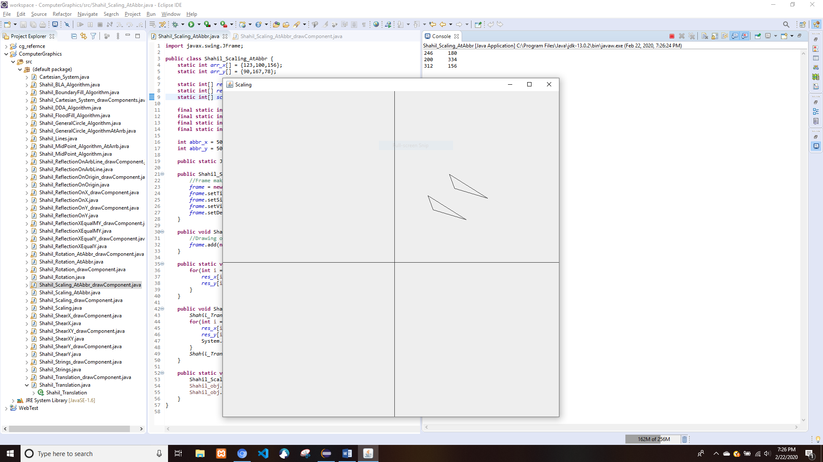

# Rotation

## About Origin

* Shahil_Rotation.java

**import** javax.swing.JFrame;

**public** **class** Shahil_Rotation {

**static** **int** *arr*[][] = {

{100, 100},

{150, 200}

};

**static** **int**[][] *result* = **new** **int**[2][2];

**final** **static** **int** ***DEFAULT_HEIGHT*** = 800;

**final** **static** **int** ***DEFAULT_WIDTH*** = 800;

**final** **static** **int** ***DEFAULT_X_MID*** = ***DEFAULT_HEIGHT***/2;

**final** **static** **int** ***DEFAULT_Y_MID*** = ***DEFAULT_WIDTH***/2;

**public** **static** JFrame *frame*;

**public** Shahil_Rotation() {

//Frame making

*frame* = **new** JFrame();

*frame*.setTitle("Anti Clockwise Rotatation");

*frame*.setSize(***DEFAULT_WIDTH***,***DEFAULT_HEIGHT***);

*frame*.setVisible(**true**);

*frame*.setDefaultCloseOperation(JFrame.***EXIT_ON_CLOSE***);

}

**public** **void** Shahil_drawQuartine(){

//Drawing of axes

*frame*.add(**new** Shahil_Rotation_drawComponent(***DEFAULT_HEIGHT***, ***DEFAULT_WIDTH***, *arr*, *result*));

}

**public** **void** Shahil_Opertaion() {

**double** angleRadian= Math.*toRadians*(180);

**for**(**int** i = 0 ; i<2; i++) {

*result*[i][0]=(**int**)Math.*round*(*arr*[i][0]*Math.*cos*(angleRadian)+*arr*[i][1]*Math.*sin*(angleRadian));

*result*[i][1]=(**int**)Math.*round*(*arr*[i][0]*Math.*sin*(angleRadian)+*arr*[i][1]*Math.*cos*(angleRadian));

}

}

**public** **static** **void** main(String[] args) {

Shahil_Rotation Shahil_obj = **new** Shahil_Rotation();

Shahil_obj.Shahil_Opertaion();

Shahil_obj.Shahil_drawQuartine();

}

}

* Shahil_Rotation_drawComponent.java

**import** java.awt.Color;

**import** java.awt.Graphics;

**import** java.awt.Graphics2D;

**import** java.awt.geom.Line2D;

**import** java.awt.geom.Point2D;

**import** javax.swing.JComponent;

**public** **class** Shahil_Rotation_drawComponent **extends** JComponent {

**static** **int** *DEFAULT_HEIGHT*;

**static** **int** *DEFAULT_WIDTH*;

**static** **int** *DEFAULT_HEIGHT_MID*;

**static** **int** *DEFAULT_WIDTH_MID*;

**static** **int** *arr*[][];

**static** **int** *result*[][];

**static** **int** *x1*,*y1*,*x2*,*y2*;

**static** **int** *a1*,*b1*,*a2*,*b2*;

Shahil_Rotation_drawComponent(**int** DEFAULT_HEIGHT, **int** DEFAULT_WIDTH, **int**[][] arr, **int**[][] result){

**this**.*DEFAULT_HEIGHT* = DEFAULT_HEIGHT;

**this**.*DEFAULT_WIDTH* = DEFAULT_WIDTH;

*DEFAULT_HEIGHT_MID* = DEFAULT_HEIGHT/2;

*DEFAULT_WIDTH_MID* = DEFAULT_WIDTH/2;

**this**.*arr* = arr;

**this**.*result* = result;

*Shahil_mapArray*();

}

**public** **static** **void** Shahil_mapArray() {

*x1* = *arr*[0][0];

*y1* = *arr*[0][1];

*x2* = *arr* [1][0];

*y2* = *arr*[1][1];

*a1* = *result*[0][0];

*b1* = *result*[0][1];

*a2* = *result* [1][0];

*b2* = *result*[1][1];

}

**public** **void** paintComponent(Graphics g){

Graphics2D g2d = (Graphics2D) g;

//Making the x and y axes

Line2D.Double x_line = **new** Line2D.Double(**new** Point2D.Double(0,*DEFAULT_HEIGHT_MID*), **new** Point2D.Double(*DEFAULT_WIDTH*,*DEFAULT_HEIGHT_MID*));

Line2D.Double y_line = **new** Line2D.Double(**new** Point2D.Double(*DEFAULT_WIDTH_MID*, 0), **new** Point2D.Double(*DEFAULT_WIDTH_MID*, *DEFAULT_HEIGHT*));

g2d.draw(x_line);

g2d.draw(y_line);

g2d.rotate(Math.*toRadians*(-90),400,400);

g2d.translate(400, 400);

Line2D.Double Line1 = **new** Line2D.Double(**new** Point2D.Double(*x1*, *y1*), **new** Point2D.Double(*x2*,*y2*));

g2d.draw(Line1);

g2d.setColor(Color.***RED***);

Line2D.Double Line2 = **new** Line2D.Double(**new** Point2D.Double(*a1*,*b1*), **new** Point2D.Double(*a2*,*b2*));

g2d.draw(Line2);

}

}

* Output

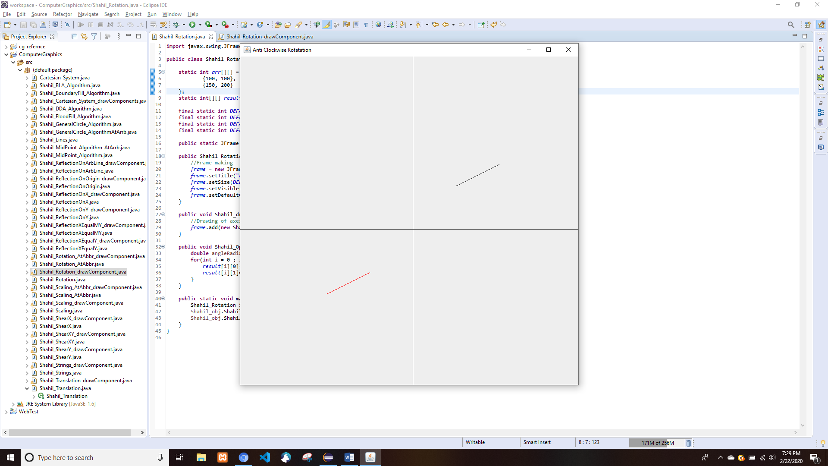

## About an Arbitrary Point

* Shahil_Rotation_AtAbbr.java

**import** javax.swing.JFrame;

**public** **class** Shahil_Rotation_AtAbbr {

**static** **int** *arr*[][] = {

{100, 100},

{150, 200}

};

**static** **int**[][] *result* = **new** **int**[2][2];

**final** **static** **int** ***DEFAULT_HEIGHT*** = 800;

**final** **static** **int** ***DEFAULT_WIDTH*** = 800;

**final** **static** **int** ***DEFAULT_X_MID*** = ***DEFAULT_HEIGHT***/2;

**final** **static** **int** ***DEFAULT_Y_MID*** = ***DEFAULT_WIDTH***/2;

**int** abbr_x = 50;//Arbitrary point x

**int** abbr_y = 50;//Arbitrary point y

**public** **static** JFrame *frame*;

**public** Shahil_Rotation_AtAbbr() {

//Frame making

*frame* = **new** JFrame();

*frame*.setTitle("Anti Clockwise Rotatation");

*frame*.setSize(***DEFAULT_WIDTH***,***DEFAULT_HEIGHT***);

*frame*.setVisible(**true**);

*frame*.setDefaultCloseOperation(JFrame.***EXIT_ON_CLOSE***);

}

**public** **void** Shahil_drawQuartine(){

//Drawing of axes

*frame*.add(**new** Shahil_Rotation_AtAbbr_drawComponent(***DEFAULT_HEIGHT***, ***DEFAULT_WIDTH***, *arr*, *result*));

}

**public** **static** **void** Shahil_Translate(**int** h, **int** k) {

**for**(**int** i = 0 ; i<2; i++) {

*result*[i][0] = *arr*[i][0] + h;

*result*[i][1] = *arr*[i][1] + k;

System.***out***.println("Translated \t"+*result*[i][0]+"\t"+*result*[i][1]);

}

}

**public** **void** Shahil_Opertaion() {

*Shahil_Translate*(-abbr_x,-abbr_y);

**double** angleRadian= Math.*toRadians*(180);

**for**(**int** i = 0 ; i<2; i++) {

*result*[i][0]=(**int**)Math.*round*(*arr*[i][0]*Math.*cos*(angleRadian)+*arr*[i][1]*Math.*sin*(angleRadian));

*result*[i][1]=(**int**)Math.*round*(*arr*[i][0]*Math.*sin*(angleRadian)+*arr*[i][1]*Math.*cos*(angleRadian));

System.***out***.println("rotated \t"+*result*[i][0]+"\t"+*result*[i][1]);

}

*Shahil_Translate*(abbr_x,abbr_y);

}

**public** **static** **void** main(String[] args) {

Shahil_Rotation_AtAbbr Shahil_obj = **new** Shahil_Rotation_AtAbbr();

Shahil_obj.Shahil_Opertaion();

Shahil_obj.Shahil_drawQuartine();

}

}

* Shahil_Rotation_AtAbbr_drawComponent.java

**import** java.awt.Color;

**import** java.awt.Graphics;

**import** java.awt.Graphics2D;

**import** java.awt.geom.Line2D;

**import** java.awt.geom.Point2D;

**import** javax.swing.JComponent;

**public** **class** Shahil_Rotation_AtAbbr_drawComponent **extends** JComponent{

**static** **int** *DEFAULT_HEIGHT*;

**static** **int** *DEFAULT_WIDTH*;

**static** **int** *DEFAULT_HEIGHT_MID*;

**static** **int** *DEFAULT_WIDTH_MID*;

**static** **int** *arr*[][];

**static** **int** *result*[][];

**static** **int** *x1*,*y1*,*x2*,*y2*;

**static** **int** *a1*,*b1*,*a2*,*b2*;

Shahil_Rotation_AtAbbr_drawComponent(**int** DEFAULT_HEIGHT, **int** DEFAULT_WIDTH, **int**[][] arr, **int**[][] result){

**this**.*DEFAULT_HEIGHT* = DEFAULT_HEIGHT;

**this**.*DEFAULT_WIDTH* = DEFAULT_WIDTH;

*DEFAULT_HEIGHT_MID* = DEFAULT_HEIGHT/2;

*DEFAULT_WIDTH_MID* = DEFAULT_WIDTH/2;

**this**.*arr* = arr;

**this**.*result* = result;

*Shahil_mapArray*();

}

**public** **static** **void** Shahil_mapArray() {

*x1* = *arr*[0][0];

*y1* = *arr*[0][1];

*x2* = *arr* [1][0];

*y2* = *arr*[1][1];

*a1* = *result*[0][0];

*b1* = *result*[0][1];

*a2* = *result* [1][0];

*b2* = *result*[1][1];

}

**public** **void** paintComponent(Graphics g){

Graphics2D g2d = (Graphics2D) g;

//Making the x and y axes

Line2D.Double x_line = **new** Line2D.Double(**new** Point2D.Double(0,*DEFAULT_HEIGHT_MID*), **new** Point2D.Double(*DEFAULT_WIDTH*,*DEFAULT_HEIGHT_MID*));

Line2D.Double y_line = **new** Line2D.Double(**new** Point2D.Double(*DEFAULT_WIDTH_MID*, 0), **new** Point2D.Double(*DEFAULT_WIDTH_MID*, *DEFAULT_HEIGHT*));

g2d.draw(x_line);

g2d.draw(y_line);

g2d.rotate(Math.*toRadians*(-90),400,400);

g2d.translate(400, 400);

Line2D.Double Line1 = **new** Line2D.Double(**new** Point2D.Double(*x1*, *y1*), **new** Point2D.Double(*x2*,*y2*));

g2d.draw(Line1);

g2d.setColor(Color.***RED***);

Line2D.Double Line2 = **new** Line2D.Double(**new** Point2D.Double(*a1*,*b1*), **new** Point2D.Double(*a2*,*b2*));

g2d.draw(Line2);

}

}

* Output

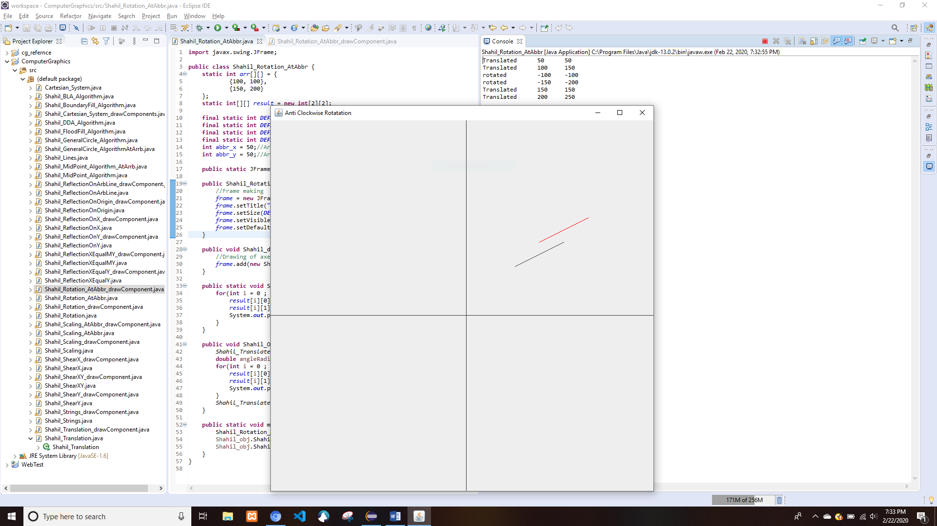

# Reflection

## About X-Axis

* Shahil_ReflectionOnX.java

**import** javax.swing.JFrame;

**public** **class** Shahil_ReflectionOnX {

**static** **int** *arr*[][] = {

{100, 100},

{150, 200}

};

**static** **int**[][] *result* = **new** **int**[2][2];

**final** **static** **int** ***DEFAULT_HEIGHT*** = 800;

**final** **static** **int** ***DEFAULT_WIDTH*** = 800;

**final** **static** **int** ***DEFAULT_X_MID*** = ***DEFAULT_HEIGHT***/2;

**final** **static** **int** ***DEFAULT_Y_MID*** = ***DEFAULT_WIDTH***/2;

**public** **static** JFrame *frame*;

**public** Shahil_ReflectionOnX() {

//Frame making

*frame* = **new** JFrame();

*frame*.setTitle("Reflection On Origin");

*frame*.setSize(***DEFAULT_WIDTH***,***DEFAULT_HEIGHT***);

*frame*.setVisible(**true**);

*frame*.setDefaultCloseOperation(JFrame.***EXIT_ON_CLOSE***);

}

**public** **void** Shahil_drawQuartine(){

//Drawing of axes

*frame*.add(**new** Shahil_ReflectionOnX_drawComponent(***DEFAULT_HEIGHT***, ***DEFAULT_WIDTH***, *arr*, *result*));

}

**public** **void** Shahil_Opertaion() {

**for**(**int** i = 0 ; i<2; i++) {

*result*[i][0] = *arr*[i][0] * -1;

*result*[i][1] = *arr*[i][1] * 1;

System.***out***.println(*result*[i][0]+"\t"+*result*[i][1]);

}

}

**public** **static** **void** main(String[] args) {

Shahil_ReflectionOnX Shahil_obj = **new** Shahil_ReflectionOnX();

Shahil_obj.Shahil_Opertaion();

Shahil_obj.Shahil_drawQuartine();

}

}

* Shahil_ReflectionOnX_drawComponent.java

**import** java.awt.Color;

**import** java.awt.Graphics;

**import** java.awt.Graphics2D;

**import** java.awt.geom.Line2D;

**import** java.awt.geom.Point2D;

**import** javax.swing.JComponent;

**public** **class** Shahil_ReflectionOnX_drawComponent **extends** JComponent {

**static** **int** *DEFAULT_HEIGHT*;

**static** **int** *DEFAULT_WIDTH*;

**static** **int** *DEFAULT_HEIGHT_MID*;

**static** **int** *DEFAULT_WIDTH_MID*;

**static** **int** *arr*[][];

**static** **int** *result*[][];

**static** **int** *x1*,*y1*,*x2*,*y2*;

**static** **int** *a1*,*b1*,*a2*,*b2*;

Shahil_ReflectionOnX_drawComponent(**int** DEFAULT_HEIGHT, **int** DEFAULT_WIDTH, **int**[][] arr, **int**[][] result){

**this**.*DEFAULT_HEIGHT* = DEFAULT_HEIGHT;

**this**.*DEFAULT_WIDTH* = DEFAULT_WIDTH;

*DEFAULT_HEIGHT_MID* = DEFAULT_HEIGHT/2;

*DEFAULT_WIDTH_MID* = DEFAULT_WIDTH/2;

**this**.*arr* = arr;

**this**.*result* = result;

*Shahil_mapArray*();

}

**public** **static** **void** Shahil_mapArray() {

*x1* = *arr*[0][0];

*y1* = *arr*[0][1];

*x2* = *arr* [1][0];

*y2* = *arr*[1][1];

*a1* = *result*[0][0];

*b1* = *result*[0][1];

*a2* = *result* [1][0];

*b2* = *result*[1][1];

}

**public** **void** paintComponent(Graphics g){

Graphics2D g2d = (Graphics2D) g;

//Making the x and y axes

Line2D.Double x_line = **new** Line2D.Double(**new** Point2D.Double(0,*DEFAULT_HEIGHT_MID*), **new** Point2D.Double(*DEFAULT_WIDTH*,*DEFAULT_HEIGHT_MID*));

Line2D.Double y_line = **new** Line2D.Double(**new** Point2D.Double(*DEFAULT_WIDTH_MID*, 0), **new** Point2D.Double(*DEFAULT_WIDTH_MID*, *DEFAULT_HEIGHT*));

g2d.draw(x_line);

g2d.draw(y_line);

g2d.rotate(Math.*toRadians*(-90),400,400);

g2d.translate(400, 400);

Line2D.Double Line1 = **new** Line2D.Double(**new** Point2D.Double(*x1*, *y1*), **new** Point2D.Double(*x2*,*y2*));

g2d.draw(Line1);

g2d.setColor(Color.***RED***);

Line2D.Double Line2 = **new** Line2D.Double(**new** Point2D.Double(*a1*,*b1*), **new** Point2D.Double(*a2*,*b2*));

g2d.draw(Line2);

}

}

* Output

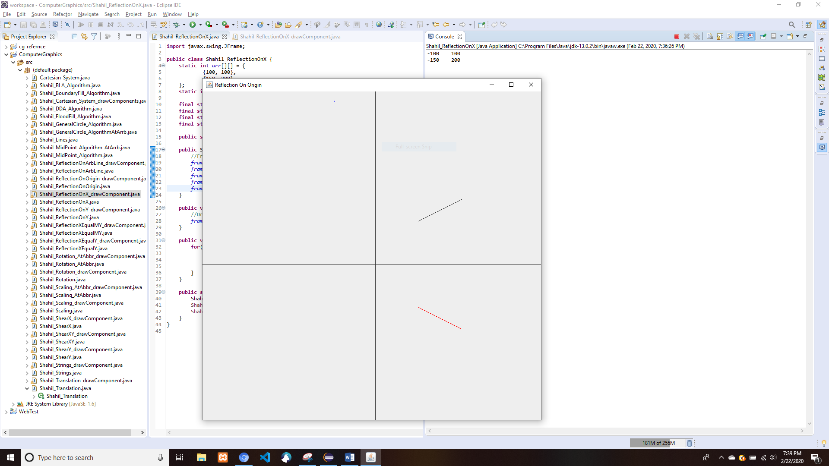

## About Y-Axis

* Shahil_ReflectionOnY.java

**import** javax.swing.JFrame;

**public** **class** Shahil_ReflectionOnY {

**static** **int** *arr*[][] = {

{100, 100},

{150, 200}

};

**static** **int**[][] *result* = **new** **int**[2][2];

**final** **static** **int** ***DEFAULT_HEIGHT*** = 800;

**final** **static** **int** ***DEFAULT_WIDTH*** = 800;

**final** **static** **int** ***DEFAULT_X_MID*** = ***DEFAULT_HEIGHT***/2;

**final** **static** **int** ***DEFAULT_Y_MID*** = ***DEFAULT_WIDTH***/2;

**public** **static** JFrame *frame*;

**public** Shahil_ReflectionOnY() {

//Frame making

*frame* = **new** JFrame();

*frame*.setTitle("Reflection On Origin");

*frame*.setSize(***DEFAULT_WIDTH***,***DEFAULT_HEIGHT***);

*frame*.setVisible(**true**);

*frame*.setDefaultCloseOperation(JFrame.***EXIT_ON_CLOSE***);

}

**public** **void** Shahil_drawQuartine(){

//Drawing of axes

*frame*.add(**new** Shahil_ReflectionOnY_drawComponent(***DEFAULT_HEIGHT***, ***DEFAULT_WIDTH***, *arr*, *result*));

}

**public** **void** Shahil_Opertaion() {

**for**(**int** i = 0 ; i<2; i++) {

*result*[i][0] = *arr*[i][0] * 1;

*result*[i][1] = *arr*[i][1] * -1;

System.***out***.println(*result*[i][0]+"\t"+*result*[i][1]);

}

}

**public** **static** **void** main(String[] args) {

Shahil_ReflectionOnY Shahil_obj = **new** Shahil_ReflectionOnY();

Shahil_obj.Shahil_Opertaion();

Shahil_obj.Shahil_drawQuartine();

}

}

* Shahil_ReflectionOnY_drawComponent.java

**import** java.awt.Color;

**import** java.awt.Graphics;

**import** java.awt.Graphics2D;

**import** java.awt.geom.Line2D;

**import** java.awt.geom.Point2D;

**import** javax.swing.JComponent;

**public** **class** Shahil_ReflectionOnY_drawComponent **extends** JComponent {

**static** **int** *DEFAULT_HEIGHT*;

**static** **int** *DEFAULT_WIDTH*;

**static** **int** *DEFAULT_HEIGHT_MID*;

**static** **int** *DEFAULT_WIDTH_MID*;

**static** **int** *arr*[][];

**static** **int** *result*[][];

**static** **int** *x1*,*y1*,*x2*,*y2*;

**static** **int** *a1*,*b1*,*a2*,*b2*;

Shahil_ReflectionOnY_drawComponent(**int** DEFAULT_HEIGHT, **int** DEFAULT_WIDTH, **int**[][] arr, **int**[][] result){

**this**.*DEFAULT_HEIGHT* = DEFAULT_HEIGHT;

**this**.*DEFAULT_WIDTH* = DEFAULT_WIDTH;

*DEFAULT_HEIGHT_MID* = DEFAULT_HEIGHT/2;

*DEFAULT_WIDTH_MID* = DEFAULT_WIDTH/2;

**this**.*arr* = arr;

**this**.*result* = result;

*Shahil_mapArray*();

}

**public** **static** **void** Shahil_mapArray() {

*x1* = *arr*[0][0];

*y1* = *arr*[0][1];

*x2* = *arr* [1][0];

*y2* = *arr*[1][1];

*a1* = *result*[0][0];

*b1* = *result*[0][1];

*a2* = *result* [1][0];

*b2* = *result*[1][1];

}

**public** **void** paintComponent(Graphics g){

Graphics2D g2d = (Graphics2D) g;

//Making the x and y axes

Line2D.Double x_line = **new** Line2D.Double(**new** Point2D.Double(0,*DEFAULT_HEIGHT_MID*), **new** Point2D.Double(*DEFAULT_WIDTH*,*DEFAULT_HEIGHT_MID*));

Line2D.Double y_line = **new** Line2D.Double(**new** Point2D.Double(*DEFAULT_WIDTH_MID*, 0), **new** Point2D.Double(*DEFAULT_WIDTH_MID*, *DEFAULT_HEIGHT*));

g2d.draw(x_line);

g2d.draw(y_line);

g2d.rotate(Math.*toRadians*(-90),400,400);

g2d.translate(400, 400);

Line2D.Double Line1 = **new** Line2D.Double(**new** Point2D.Double(*x1*, *y1*), **new** Point2D.Double(*x2*,*y2*));

g2d.draw(Line1);

g2d.setColor(Color.***RED***);

Line2D.Double Line2 = **new** Line2D.Double(**new** Point2D.Double(*a1*,*b1*), **new** Point2D.Double(*a2*,*b2*));

g2d.draw(Line2);

}

}

* Output

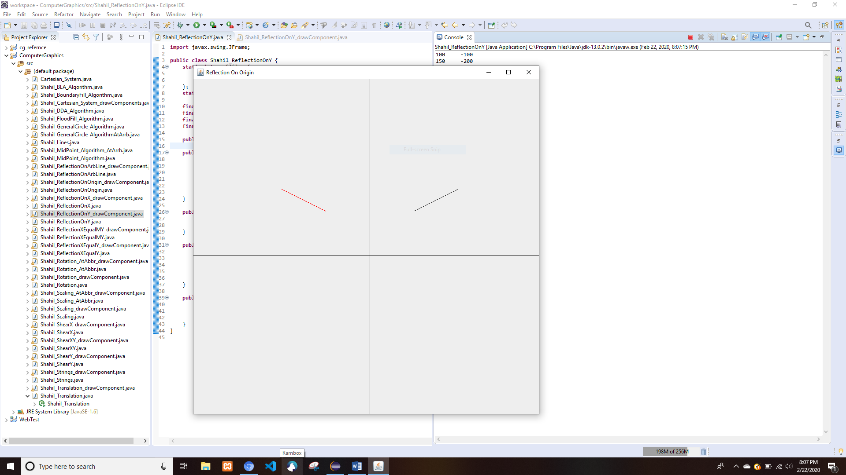

## About Y=X

* Shahil_ReflectionXEqualY.java

**import** javax.swing.JFrame;

**public** **class** Shahil_ReflectionXEqualY {

**static** **int** *arr*[][] = {

{150, 100},

{300, 200}

};

**static** **int**[][] *result* = **new** **int**[2][2];

**final** **static** **int** ***DEFAULT_HEIGHT*** = 800;

**final** **static** **int** ***DEFAULT_WIDTH*** = 800;

**final** **static** **int** ***DEFAULT_X_MID*** = ***DEFAULT_HEIGHT***/2;

**final** **static** **int** ***DEFAULT_Y_MID*** = ***DEFAULT_WIDTH***/2;

**public** **static** JFrame *frame*;

**public** Shahil_ReflectionXEqualY() {

//Frame making

*frame* = **new** JFrame();

*frame*.setTitle("Reflection On Origin");

*frame*.setSize(***DEFAULT_WIDTH***,***DEFAULT_HEIGHT***);

*frame*.setVisible(**true**);

*frame*.setDefaultCloseOperation(JFrame.***EXIT_ON_CLOSE***);

}

**public** **void** Shahil_drawQuartine(){

//Drawing of axes

*frame*.add(**new** Shahil_ReflectionXEqualY_drawComponent(***DEFAULT_HEIGHT***, ***DEFAULT_WIDTH***, *arr*, *result*));

}

**public** **void** Shahil_Opertaion() {

**for**(**int** i = 0 ; i<2; i++) {

*result*[i][0] = *arr*[i][1];

*result*[i][1] = *arr*[i][0];

System.***out***.println(*result*[i][0]+"\t"+*result*[i][1]);

}

}

**public** **static** **void** main(String[] args) {

Shahil_ReflectionXEqualY Shahil_obj = **new** Shahil_ReflectionXEqualY();

Shahil_obj.Shahil_Opertaion();

Shahil_obj.Shahil_drawQuartine();

}

}

* Shahil_ReflectionXEqualY_drawComponent.java

**import** java.awt.Color;

**import** java.awt.Graphics;

**import** java.awt.Graphics2D;

**import** java.awt.geom.Line2D;

**import** java.awt.geom.Point2D;

**import** javax.swing.JComponent;

**public** **class** Shahil_ReflectionXEqualY_drawComponent **extends** JComponent {

**static** **int** *DEFAULT_HEIGHT*;

**static** **int** *DEFAULT_WIDTH*;

**static** **int** *DEFAULT_HEIGHT_MID*;

**static** **int** *DEFAULT_WIDTH_MID*;

**static** **int** *arr*[][];

**static** **int** *result*[][];

**static** **int** *x1*,*y1*,*x2*,*y2*;

**static** **int** *a1*,*b1*,*a2*,*b2*;

Shahil_ReflectionXEqualY_drawComponent(**int** DEFAULT_HEIGHT, **int** DEFAULT_WIDTH, **int**[][] arr, **int**[][] result){

**this**.*DEFAULT_HEIGHT* = DEFAULT_HEIGHT;

**this**.*DEFAULT_WIDTH* = DEFAULT_WIDTH;

*DEFAULT_HEIGHT_MID* = DEFAULT_HEIGHT/2;

*DEFAULT_WIDTH_MID* = DEFAULT_WIDTH/2;

**this**.*arr* = arr;

**this**.*result* = result;

*Shahil_mapArray*();

}

**public** **static** **void** Shahil_mapArray() {

*x1* = *arr*[0][0];

*y1* = *arr*[0][1];

*x2* = *arr* [1][0];

*y2* = *arr*[1][1];

*a1* = *result*[0][0];

*b1* = *result*[0][1];

*a2* = *result* [1][0];

*b2* = *result*[1][1];

}

**public** **void** paintComponent(Graphics g){

Graphics2D g2d = (Graphics2D) g;

//Making the x and y axes

Line2D.Double x_line = **new** Line2D.Double(**new** Point2D.Double(0,*DEFAULT_HEIGHT_MID*), **new** Point2D.Double(*DEFAULT_WIDTH*,*DEFAULT_HEIGHT_MID*));

Line2D.Double y_line = **new** Line2D.Double(**new** Point2D.Double(*DEFAULT_WIDTH_MID*, 0), **new** Point2D.Double(*DEFAULT_WIDTH_MID*, *DEFAULT_HEIGHT*));

g2d.draw(x_line);

g2d.draw(y_line);

g2d.rotate(Math.*toRadians*(-90),400,400);

g2d.translate(400, 400);

Line2D.Double Line1 = **new** Line2D.Double(**new** Point2D.Double(*x1*, *y1*), **new** Point2D.Double(*x2*,*y2*));

g2d.draw(Line1);

g2d.setColor(Color.***RED***);

Line2D.Double Line2 = **new** Line2D.Double(**new** Point2D.Double(*a1*,*b1*), **new** Point2D.Double(*a2*,*b2*));

g2d.draw(Line2);

}

}

* Output

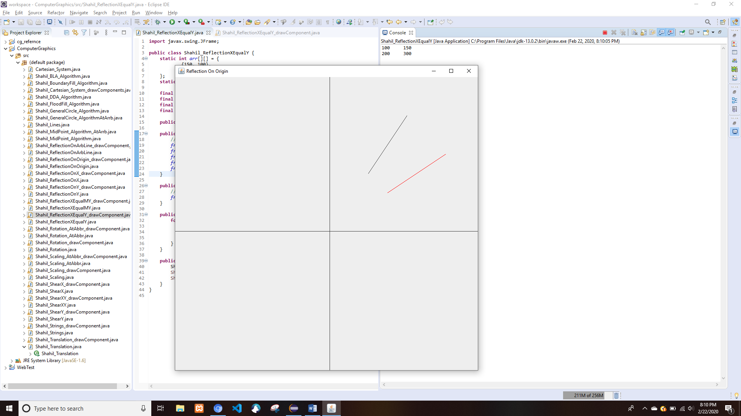

## About Y=-X

* Shahil_ReflectionXEqualMY.java

**import** javax.swing.JFrame;

**public** **class** Shahil_ReflectionXEqualMY {

**static** **int** *arr*[][] = {

{150, 100},

{300, 200}

};

**static** **int**[][] *result* = **new** **int**[2][2];

**final** **static** **int** ***DEFAULT_HEIGHT*** = 800;

**final** **static** **int** ***DEFAULT_WIDTH*** = 800;

**final** **static** **int** ***DEFAULT_X_MID*** = ***DEFAULT_HEIGHT***/2;

**final** **static** **int** ***DEFAULT_Y_MID*** = ***DEFAULT_WIDTH***/2;

**public** **static** JFrame *frame*;

**public** Shahil_ReflectionXEqualMY() {

//Frame making

*frame* = **new** JFrame();

*frame*.setTitle("Reflection On Origin");

*frame*.setSize(***DEFAULT_WIDTH***,***DEFAULT_HEIGHT***);

*frame*.setVisible(**true**);

*frame*.setDefaultCloseOperation(JFrame.***EXIT_ON_CLOSE***);

}

**public** **void** Shahil_drawQuartine(){

//Drawing of axes

*frame*.add(**new** Shahil_ReflectionXEqualY_drawComponent(***DEFAULT_HEIGHT***, ***DEFAULT_WIDTH***, *arr*, *result*));

}

**public** **void** Shahil_Opertaion() {

**for**(**int** i = 0 ; i<2; i++) {

*result*[i][0] = -*arr*[i][1];

*result*[i][1] = -*arr*[i][0];

System.***out***.println(*result*[i][0]+"\t"+*result*[i][1]);

}

}

**public** **static** **void** main(String[] args) {

Shahil_ReflectionXEqualMY Shahil_obj = **new** Shahil_ReflectionXEqualMY();

Shahil_obj.Shahil_Opertaion();

Shahil_obj.Shahil_drawQuartine();

}

}

* Shahil_ReflectionXEqualMY_drawComponent.java

**import** java.awt.Color;

**import** java.awt.Graphics;

**import** java.awt.Graphics2D;

**import** java.awt.geom.Line2D;

**import** java.awt.geom.Point2D;

**import** javax.swing.JComponent;

**public** **class** Shahil_ReflectionXEqualMY_drawComponent **extends** JComponent{

**static** **int** *DEFAULT_HEIGHT*;

**static** **int** *DEFAULT_WIDTH*;

**static** **int** *DEFAULT_HEIGHT_MID*;

**static** **int** *DEFAULT_WIDTH_MID*;

**static** **int** *arr*[][];

**static** **int** *result*[][];

**static** **int** *x1*,*y1*,*x2*,*y2*;

**static** **int** *a1*,*b1*,*a2*,*b2*;

Shahil_ReflectionXEqualMY_drawComponent(**int** DEFAULT_HEIGHT, **int** DEFAULT_WIDTH, **int**[][] arr, **int**[][] result){

**this**.*DEFAULT_HEIGHT* = DEFAULT_HEIGHT;

**this**.*DEFAULT_WIDTH* = DEFAULT_WIDTH;

*DEFAULT_HEIGHT_MID* = DEFAULT_HEIGHT/2;

*DEFAULT_WIDTH_MID* = DEFAULT_WIDTH/2;

**this**.*arr* = arr;

**this**.*result* = result;

*Shahil_mapArray*();

}

**public** **static** **void** Shahil_mapArray() {

*x1* = *arr*[0][0];

*y1* = *arr*[0][1];

*x2* = *arr* [1][0];

*y2* = *arr*[1][1];

*a1* = *result*[0][0];

*b1* = *result*[0][1];

*a2* = *result* [1][0];

*b2* = *result*[1][1];

}

**public** **void** paintComponent(Graphics g){

Graphics2D g2d = (Graphics2D) g;

//Making the x and y axes

Line2D.Double x_line = **new** Line2D.Double(**new** Point2D.Double(0,*DEFAULT_HEIGHT_MID*), **new** Point2D.Double(*DEFAULT_WIDTH*,*DEFAULT_HEIGHT_MID*));

Line2D.Double y_line = **new** Line2D.Double(**new** Point2D.Double(*DEFAULT_WIDTH_MID*, 0), **new** Point2D.Double(*DEFAULT_WIDTH_MID*, *DEFAULT_HEIGHT*));

g2d.draw(x_line);

g2d.draw(y_line);

g2d.rotate(Math.*toRadians*(-90),400,400);

g2d.translate(400, 400);

Line2D.Double Line1 = **new** Line2D.Double(**new** Point2D.Double(*x1*, *y1*), **new** Point2D.Double(*x2*,*y2*));

g2d.draw(Line1);

g2d.setColor(Color.***RED***);

Line2D.Double Line2 = **new** Line2D.Double(**new** Point2D.Double(*a1*,*b1*), **new** Point2D.Double(*a2*,*b2*));

g2d.draw(Line2);

}

}

* Output

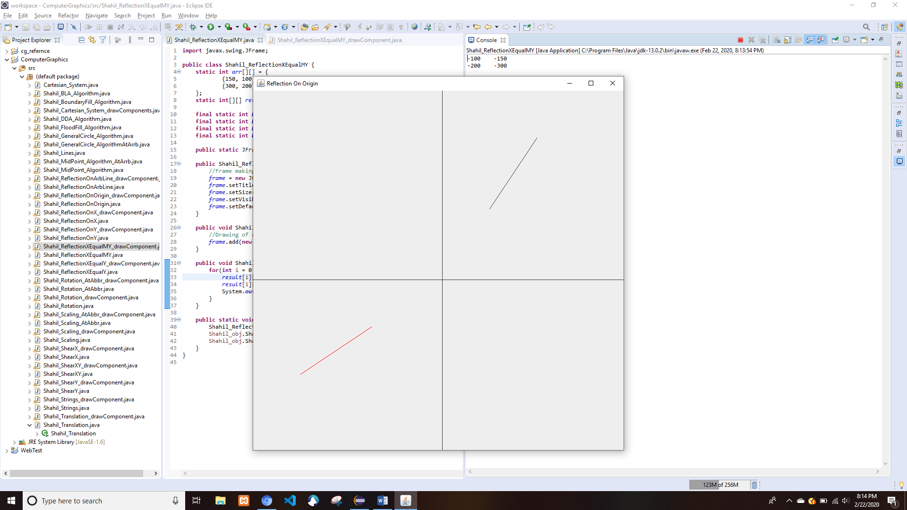

## About Origin

* Shahil_ReflectionOnOrigin.java

**import** javax.swing.JFrame;

**public** **class** Shahil_ReflectionOnOrigin {

**static** **int** *arr*[][] = {

{100, 100},

{150, 200}

};

**static** **int**[][] *result* = **new** **int**[2][2];

**final** **static** **int** ***DEFAULT_HEIGHT*** = 800;

**final** **static** **int** ***DEFAULT_WIDTH*** = 800;

**final** **static** **int** ***DEFAULT_X_MID*** = ***DEFAULT_HEIGHT***/2;

**final** **static** **int** ***DEFAULT_Y_MID*** = ***DEFAULT_WIDTH***/2;

**public** **static** JFrame *frame*;

**public** Shahil_ReflectionOnOrigin() {

//Frame making

*frame* = **new** JFrame();

*frame*.setTitle("Reflection On Origin");

*frame*.setSize(***DEFAULT_WIDTH***,***DEFAULT_HEIGHT***);

*frame*.setVisible(**true**);

*frame*.setDefaultCloseOperation(JFrame.***EXIT_ON_CLOSE***);

}

**public** **void** Shahil_drawQuartine(){

//Drawing of axes

*frame*.add(**new** Shahil_ReflectionOnOrigin_drawComponent(***DEFAULT_HEIGHT***, ***DEFAULT_WIDTH***, *arr*, *result*));

}

**public** **void** Shahil_Opertaion() {

**for**(**int** i = 0 ; i<2; i++) {

*result*[i][0] = *arr*[i][0] * -1;

*result*[i][1] = *arr*[i][1] * -1;

System.***out***.println(*result*[i][0]+"\t"+*result*[i][1]);

}

}

**public** **static** **void** main(String[] args) {

Shahil_ReflectionOnOrigin Shahil_obj = **new** Shahil_ReflectionOnOrigin();

Shahil_obj.Shahil_Opertaion();

Shahil_obj.Shahil_drawQuartine();

}

}

* Shahil_ReflectionOnOrigin_drawComponent.java

**import** java.awt.Color;

**import** java.awt.Graphics;

**import** java.awt.Graphics2D;

**import** java.awt.geom.Line2D;

**import** java.awt.geom.Point2D;

**import** javax.swing.JComponent;

**public** **class** Shahil_ReflectionOnOrigin_drawComponent **extends** JComponent {

**static** **int** *DEFAULT_HEIGHT*;

**static** **int** *DEFAULT_WIDTH*;

**static** **int** *DEFAULT_HEIGHT_MID*;

**static** **int** *DEFAULT_WIDTH_MID*;

**static** **int** *arr*[][];

**static** **int** *result*[][];

**static** **int** *x1*,*y1*,*x2*,*y2*;

**static** **int** *a1*,*b1*,*a2*,*b2*;

Shahil_ReflectionOnOrigin_drawComponent(**int** DEFAULT_HEIGHT, **int** DEFAULT_WIDTH, **int**[][] arr, **int**[][] result){

**this**.*DEFAULT_HEIGHT* = DEFAULT_HEIGHT;

**this**.*DEFAULT_WIDTH* = DEFAULT_WIDTH;

*DEFAULT_HEIGHT_MID* = DEFAULT_HEIGHT/2;

*DEFAULT_WIDTH_MID* = DEFAULT_WIDTH/2;

**this**.*arr* = arr;

**this**.*result* = result;

*Shahil_mapArray*();

}

**public** **static** **void** Shahil_mapArray() {

*x1* = *arr*[0][0];

*y1* = *arr*[0][1];

*x2* = *arr* [1][0];

*y2* = *arr*[1][1];

*a1* = *result*[0][0];

*b1* = *result*[0][1];

*a2* = *result* [1][0];

*b2* = *result*[1][1];

}

**public** **void** paintComponent(Graphics g){

Graphics2D g2d = (Graphics2D) g;

//Making the x and y axes

Line2D.Double x_line = **new** Line2D.Double(**new** Point2D.Double(0,*DEFAULT_HEIGHT_MID*), **new** Point2D.Double(*DEFAULT_WIDTH*,*DEFAULT_HEIGHT_MID*));

Line2D.Double y_line = **new** Line2D.Double(**new** Point2D.Double(*DEFAULT_WIDTH_MID*, 0), **new** Point2D.Double(*DEFAULT_WIDTH_MID*, *DEFAULT_HEIGHT*));

g2d.draw(x_line);

g2d.draw(y_line);

g2d.rotate(Math.*toRadians*(-90),400,400);

g2d.translate(400, 400);

Line2D.Double Line1 = **new** Line2D.Double(**new** Point2D.Double(*x1*, *y1*), **new** Point2D.Double(*x2*,*y2*));

g2d.draw(Line1);

g2d.setColor(Color.***RED***);

Line2D.Double Line2 = **new** Line2D.Double(**new** Point2D.Double(*a1*,*b1*), **new** Point2D.Double(*a2*,*b2*));

g2d.draw(Line2);

}

}

* Output

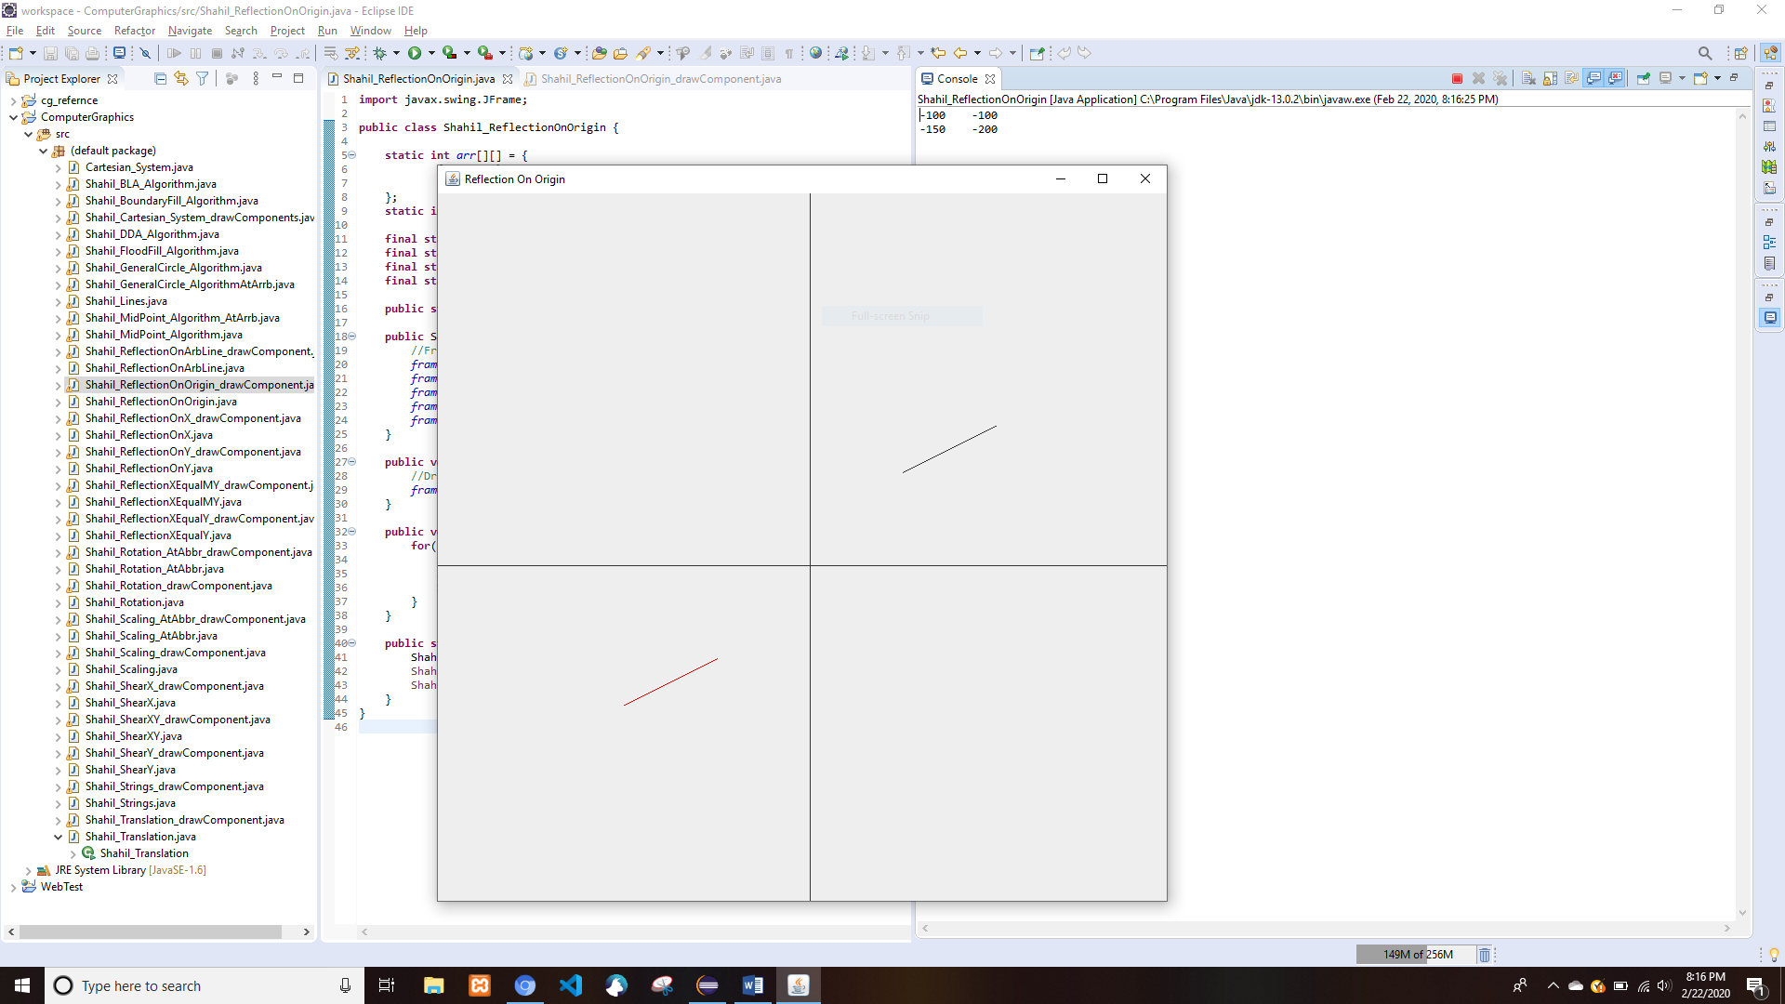

## About an Arbitrary Line

* Shahil_ReflectionOnArbLine.java

**import** javax.swing.JFrame;

//reflecting on arbitrary line with the equation y = m + 50

**public** **class** Shahil_ReflectionOnArbLine {

**static** **int** *arr*[][] = {

{90, 100},

{200, 300}

};

**static** **int**[][] *result* = **new** **int**[2][2];

**static** **int** *c* = 100;

**static** **int**[] *translate_factor* = {0, *c*};

**final** **static** **int** ***DEFAULT_HEIGHT*** = 800;

**final** **static** **int** ***DEFAULT_WIDTH*** = 800;

**final** **static** **int** ***DEFAULT_X_MID*** = ***DEFAULT_HEIGHT***/2;

**final** **static** **int** ***DEFAULT_Y_MID*** = ***DEFAULT_WIDTH***/2;

**public** **static** JFrame *frame*;

**public** Shahil_ReflectionOnArbLine() {

//Frame making

*frame* = **new** JFrame();

*frame*.setTitle("Reflection On Origin");

*frame*.setSize(***DEFAULT_WIDTH***,***DEFAULT_HEIGHT***);

*frame*.setVisible(**true**);

*frame*.setDefaultCloseOperation(JFrame.***EXIT_ON_CLOSE***);

}

**public** **void** Shahil_drawQuartine(){

//Drawing of axes

*frame*.add(**new** Shahil_ReflectionOnArbLine_drawComponent(***DEFAULT_HEIGHT***, ***DEFAULT_WIDTH***, *arr*, *result*));

}

**public** **void** Shahil_Translate(**int** a, **int** b) {

**for**(**int** i = 0 ; i<2; i++) {

*arr*[i][0] = *arr*[i][0] + a;

*arr*[i][1] = *arr*[i][1] + b;

}

}

**public** **void** Shahil_Rotate(**double** m) {

**double** angleRadian= Math.*toRadians*(m);

**for**(**int** i = 0 ; i<2; i++) {

*arr*[i][0]=(**int**)Math.*round*(*arr*[i][0]*Math.*cos*(angleRadian)+*arr*[i][1]*Math.*sin*(angleRadian));

*arr*[i][1]=(**int**)Math.*round*(*arr*[i][0]*Math.*sin*(angleRadian)+*arr*[i][1]*Math.*cos*(angleRadian));

}

}

**public** **void** Shahil_Opertaion() {

**double** m = Math.*toRadians*(Math.*atan2*((*arr*[1][1]-*arr*[0][1]),(*arr*[1][0]-*arr*[0][0])));

**double** ang = Math.*toRadians*(Math.*atan*(m));

Shahil_Translate(0, -*c*);

Shahil_Rotate(ang);

**for**(**int** i = 0 ; i<2; i++) {

*result*[i][0] = *arr*[i][0] * 1;

*result*[i][1] = *arr*[i][1] * -1;

// System.out.println(result[i][0]+"\t"+result[i][1]);

}

Shahil_Rotate(-ang);

Shahil_Translate(0, *c*);

}

**public** **static** **void** main(String[] args) {

Shahil_ReflectionOnArbLine Shahil_obj = **new** Shahil_ReflectionOnArbLine();

Shahil_obj.Shahil_Opertaion();

Shahil_obj.Shahil_drawQuartine();

}

}

* Shahil_ReflectionOnArbLine_drawComponent.java

**import** java.awt.Color;

**import** java.awt.Graphics;

**import** java.awt.Graphics2D;

**import** java.awt.geom.Line2D;

**import** java.awt.geom.Point2D;

**import** javax.swing.JComponent;

**public** **class** Shahil_ReflectionOnArbLine_drawComponent **extends** JComponent{

**static** **int** *DEFAULT_HEIGHT*;

**static** **int** *DEFAULT_WIDTH*;

**static** **int** *DEFAULT_HEIGHT_MID*;

**static** **int** *DEFAULT_WIDTH_MID*;

**static** **int** *arr*[][];

**static** **int** *result*[][];

**static** **int** *x1*,*y1*,*x2*,*y2*;

**static** **int** *a1*,*b1*,*a2*,*b2*;

Shahil_ReflectionOnArbLine_drawComponent(**int** DEFAULT_HEIGHT, **int** DEFAULT_WIDTH, **int**[][] arr, **int**[][] result){

**this**.*DEFAULT_HEIGHT* = DEFAULT_HEIGHT;

**this**.*DEFAULT_WIDTH* = DEFAULT_WIDTH;

*DEFAULT_HEIGHT_MID* = DEFAULT_HEIGHT/2;

*DEFAULT_WIDTH_MID* = DEFAULT_WIDTH/2;

**this**.*arr* = arr;

**this**.*result* = result;

*Shahil_mapArray*();

}

**public** **static** **void** Shahil_mapArray() {

*x1* = *arr*[0][0];

*y1* = *arr*[0][1];

*x2* = *arr* [1][0];

*y2* = *arr*[1][1];

*a1* = *result*[0][0];

*b1* = *result*[0][1];

*a2* = *result* [1][0];

*b2* = *result*[1][1];

}

**public** **void** paintComponent(Graphics g){

Graphics2D g2d = (Graphics2D) g;

//Making the x and y axes

Line2D.Double x_line = **new** Line2D.Double(**new** Point2D.Double(0,*DEFAULT_HEIGHT_MID*), **new** Point2D.Double(*DEFAULT_WIDTH*,*DEFAULT_HEIGHT_MID*));

Line2D.Double y_line = **new** Line2D.Double(**new** Point2D.Double(*DEFAULT_WIDTH_MID*, 0), **new** Point2D.Double(*DEFAULT_WIDTH_MID*, *DEFAULT_HEIGHT*));

g2d.draw(x_line);

g2d.draw(y_line);

g2d.rotate(Math.*toRadians*(-90),400,400);

g2d.translate(400, 400);

Line2D.Double Line1 = **new** Line2D.Double(**new** Point2D.Double(*x1*, *y1*), **new** Point2D.Double(*x2*,*y2*));

g2d.draw(Line1);

g2d.setColor(Color.***RED***);

Line2D.Double Line2 = **new** Line2D.Double(**new** Point2D.Double(*a1*,*b1*), **new** Point2D.Double(*a2*,*b2*));

g2d.draw(Line2);

}

}

* Output

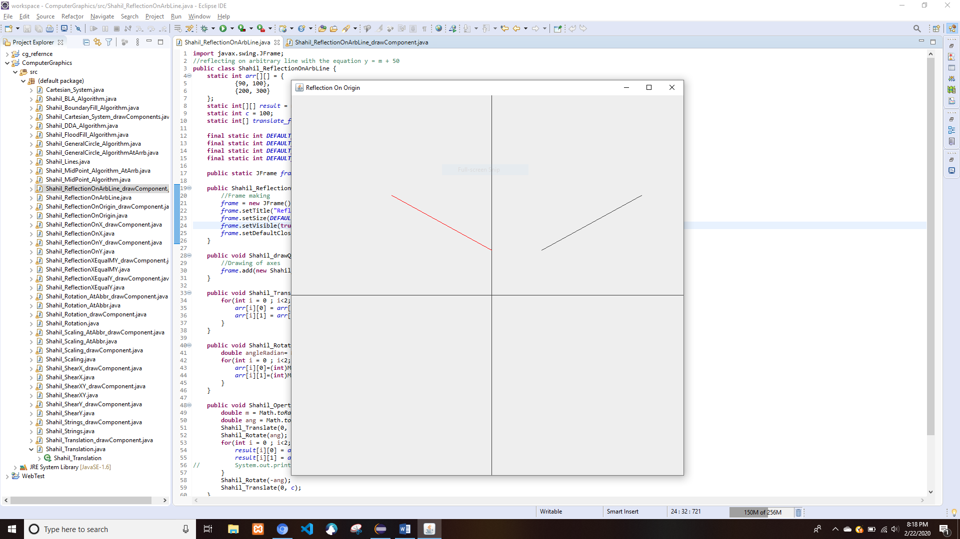

# Shear

## In X Direction

* Shahil_ShearX.java

**import** javax.swing.JFrame;

**public** **class** Shahil_ShearX {

**static** **int** *arr_x*[] = {10,10,200};

**static** **int** *arr_y*[] = {80,150,0};

**static** **int**[] *res_x* = **new** **int**[3];

**static** **int**[] *res_y* = **new** **int**[3];

**int** shy = 2;

**final** **static** **int** ***DEFAULT_HEIGHT*** = 800;

**final** **static** **int** ***DEFAULT_WIDTH*** = 800;

**final** **static** **int** ***DEFAULT_X_MID*** = ***DEFAULT_HEIGHT***/2;

**final** **static** **int** ***DEFAULT_Y_MID*** = ***DEFAULT_WIDTH***/2;

**public** **static** JFrame *frame*;

**public** Shahil_ShearX() {

//Frame making

*frame* = **new** JFrame();

*frame*.setTitle("X-Direction Shear of a triangle");

*frame*.setSize(***DEFAULT_WIDTH***,***DEFAULT_HEIGHT***);

*frame*.setVisible(**true**);

*frame*.setDefaultCloseOperation(JFrame.***EXIT_ON_CLOSE***);

}

**public** **void** Shahil_drawQuartine(){

//Drawing of axes

*frame*.add(**new** Shahil_ShearX_drawComponent(***DEFAULT_HEIGHT***, ***DEFAULT_WIDTH***, *arr_x*, *arr_y* , *res_x*, *res_y*));

}

**public** **void** Shahil_Opertaion() {

**for**(**int** i = 0 ; i<3; i++) {

*res_x*[i] = *arr_x*[i];

*res_y*[i] = *arr_y*[i] + shy * *arr_x*[i];

System.***out***.println(*res_x*[i]+"\t"+*res_y*[i]);

}

}

**public** **static** **void** main(String[] args) {

Shahil_ShearX Shahil_obj = **new** Shahil_ShearX();

Shahil_obj.Shahil_Opertaion();

Shahil_obj.Shahil_drawQuartine();

}

}

* Shahil_ShearX_drawComponent.java

**import** java.awt.Color;

**import** java.awt.Graphics;

**import** java.awt.Graphics2D;

**import** java.awt.geom.Line2D;

**import** java.awt.geom.Point2D;

**import** javax.swing.JComponent;

**public** **class** Shahil_ShearX_drawComponent **extends** JComponent{

**static** **int** *DEFAULT_HEIGHT*;

**static** **int** *DEFAULT_WIDTH*;

**static** **int** *DEFAULT_HEIGHT_MID*;

**static** **int** *DEFAULT_WIDTH_MID*;

**static** **int** *arr_x*[];

**static** **int** *arr_y*[];

**static** **int** *res_x*[];

**static** **int** *res_y*[];

**static** **int** *x1*, *x2*, *x3*;

**static** **int** *y1*, *y2*, *y3*;

Shahil_ShearX_drawComponent(**int** DEFAULT_HEIGHT, **int** DEFAULT_WIDTH, **int**[] arr_x, **int**[] arr_y, **int**[] res_x, **int**[] res_y){

**this**.*DEFAULT_HEIGHT* = DEFAULT_HEIGHT;

**this**.*DEFAULT_WIDTH* = DEFAULT_WIDTH;

*DEFAULT_HEIGHT_MID* = DEFAULT_HEIGHT/2;

*DEFAULT_WIDTH_MID* = DEFAULT_WIDTH/2;

**this**.*arr_x* = arr_x;

**this**.*arr_y* = arr_y;

**this**.*res_x* = res_x;

**this**.*res_y* = res_y;

}

**public** **void** paintComponent(Graphics g){

Graphics2D g2d = (Graphics2D) g;

//Making the x and y axes

Line2D.Double x_line = **new** Line2D.Double(**new** Point2D.Double(0,*DEFAULT_HEIGHT_MID*), **new** Point2D.Double(*DEFAULT_WIDTH*,*DEFAULT_HEIGHT_MID*));

Line2D.Double y_line = **new** Line2D.Double(**new** Point2D.Double(*DEFAULT_WIDTH_MID*, 0), **new** Point2D.Double(*DEFAULT_WIDTH_MID*, *DEFAULT_HEIGHT*));

g2d.draw(x_line);

g2d.draw(y_line);

g2d.rotate(Math.*toRadians*(-90),400,400);

g2d.translate(400, 400);

g2d.drawPolygon(*arr_x*, *arr_y*, *arr_x*.length);

g2d.drawPolygon(*res_x*, *res_y*, *res_x*.length);

}

}

* Output

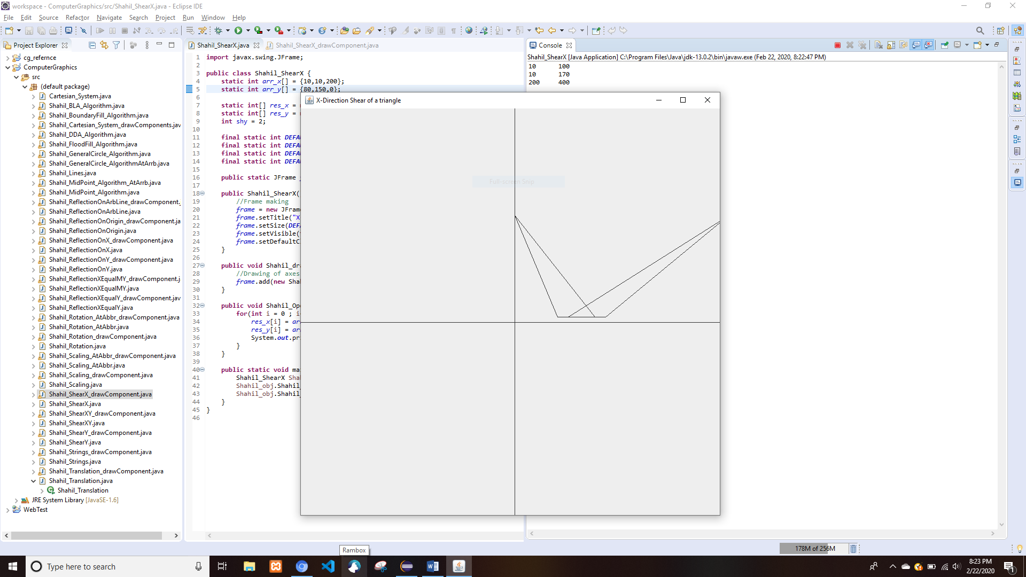

## In Y Direction

* Shahil_ShearY.java

**import** javax.swing.JFrame;

**public** **class** Shahil_ShearY {

**static** **int** *arr_x*[] = {10,10,200};

**static** **int** *arr_y*[] = {80,150,0};

**static** **int**[] *res_x* = **new** **int**[3];

**static** **int**[] *res_y* = **new** **int**[3];

**int** shx = 2;

**final** **static** **int** ***DEFAULT_HEIGHT*** = 800;

**final** **static** **int** ***DEFAULT_WIDTH*** = 800;

**final** **static** **int** ***DEFAULT_X_MID*** = ***DEFAULT_HEIGHT***/2;

**final** **static** **int** ***DEFAULT_Y_MID*** = ***DEFAULT_WIDTH***/2;

**public** **static** JFrame *frame*;

**public** Shahil_ShearY() {

//Frame making

*frame* = **new** JFrame();

*frame*.setTitle("Y-Direction Shear of a triangle");

*frame*.setSize(***DEFAULT_WIDTH***,***DEFAULT_HEIGHT***);

*frame*.setVisible(**true**);

*frame*.setDefaultCloseOperation(JFrame.***EXIT_ON_CLOSE***);

}

**public** **void** Shahil_drawQuartine(){

//Drawing of axes

*frame*.add(**new** Shahil_ShearY_drawComponent(***DEFAULT_HEIGHT***, ***DEFAULT_WIDTH***, *arr_x*, *arr_y* , *res_x*, *res_y*));

}

**public** **void** Shahil_Opertaion() {

**for**(**int** i = 0 ; i<3; i++) {

*res_x*[i] = *arr_x*[i] + shx * *arr_y*[i];

*res_y*[i] = *arr_y*[i];

System.***out***.println(*res_x*[i]+"\t"+*res_y*[i]);

}

}

**public** **static** **void** main(String[] args) {

Shahil_ShearY Shahil_obj = **new** Shahil_ShearY();

Shahil_obj.Shahil_Opertaion();

Shahil_obj.Shahil_drawQuartine();

}

}

* Shahil_ShearY_drawComponent.java

**import** java.awt.Graphics;

**import** java.awt.Graphics2D;

**import** java.awt.geom.Line2D;

**import** java.awt.geom.Point2D;

**import** javax.swing.JComponent;

**public** **class** Shahil_ShearY_drawComponent **extends** JComponent{

**static** **int** *DEFAULT_HEIGHT*;

**static** **int** *DEFAULT_WIDTH*;

**static** **int** *DEFAULT_HEIGHT_MID*;

**static** **int** *DEFAULT_WIDTH_MID*;

**static** **int** *arr_x*[];

**static** **int** *arr_y*[];

**static** **int** *res_x*[];

**static** **int** *res_y*[];

**static** **int** *x1*, *x2*, *x3*;

**static** **int** *y1*, *y2*, *y3*;

Shahil_ShearY_drawComponent(**int** DEFAULT_HEIGHT, **int** DEFAULT_WIDTH, **int**[] arr_x, **int**[] arr_y, **int**[] res_x, **int**[] res_y){

**this**.*DEFAULT_HEIGHT* = DEFAULT_HEIGHT;

**this**.*DEFAULT_WIDTH* = DEFAULT_WIDTH;

*DEFAULT_HEIGHT_MID* = DEFAULT_HEIGHT/2;

*DEFAULT_WIDTH_MID* = DEFAULT_WIDTH/2;

**this**.*arr_x* = arr_x;

**this**.*arr_y* = arr_y;

**this**.*res_x* = res_x;

**this**.*res_y* = res_y;

}

**public** **void** paintComponent(Graphics g){

Graphics2D g2d = (Graphics2D) g;

//Making the x and y axes

Line2D.Double x_line = **new** Line2D.Double(**new** Point2D.Double(0,*DEFAULT_HEIGHT_MID*), **new** Point2D.Double(*DEFAULT_WIDTH*,*DEFAULT_HEIGHT_MID*));

Line2D.Double y_line = **new** Line2D.Double(**new** Point2D.Double(*DEFAULT_WIDTH_MID*, 0), **new** Point2D.Double(*DEFAULT_WIDTH_MID*, *DEFAULT_HEIGHT*));

g2d.draw(x_line);

g2d.draw(y_line);

g2d.rotate(Math.*toRadians*(-90),400,400);

g2d.translate(400, 400);

g2d.drawPolygon(*arr_x*, *arr_y*, *arr_x*.length);

g2d.drawPolygon(*res_x*, *res_y*, *res_x*.length);

}

}

* Output

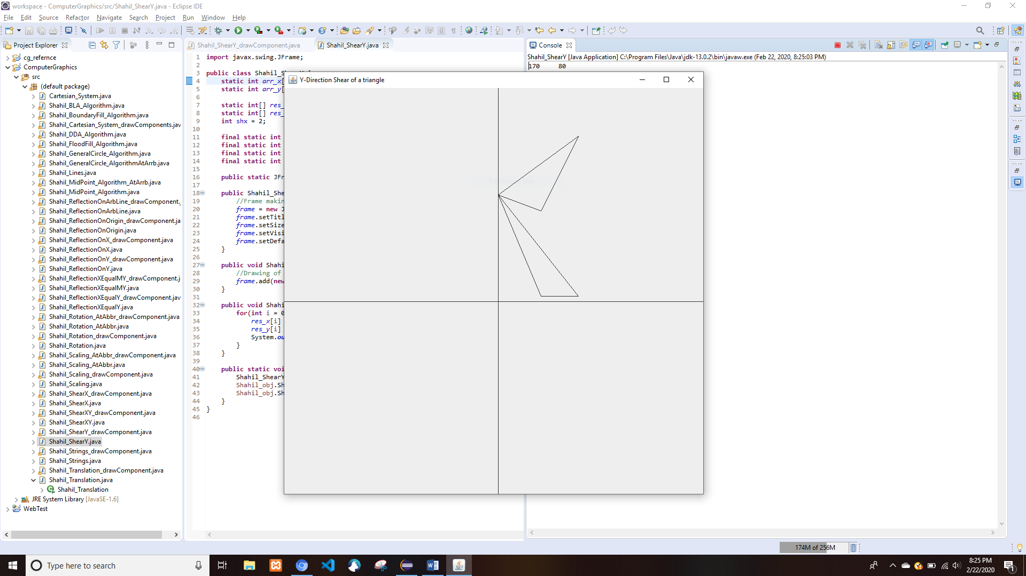

## In XY Direction

* Shahil_ShearXY.java

**import** javax.swing.JFrame;

**public** **class** Shahil_ShearXY {

**static** **int** *arr_x*[] = {10,10,150};

**static** **int** *arr_y*[] = {80,150,0};

**static** **int**[] *res_x* = **new** **int**[3];

**static** **int**[] *res_y* = **new** **int**[3];

**int** shx = 2;

**int** shy = 2;

**final** **static** **int** ***DEFAULT_HEIGHT*** = 800;

**final** **static** **int** ***DEFAULT_WIDTH*** = 800;

**final** **static** **int** ***DEFAULT_X_MID*** = ***DEFAULT_HEIGHT***/2;

**final** **static** **int** ***DEFAULT_Y_MID*** = ***DEFAULT_WIDTH***/2;

**public** **static** JFrame *frame*;

**public** Shahil_ShearXY() {

//Frame making

*frame* = **new** JFrame();

*frame*.setTitle("Y-Direction Shear of a triangle");

*frame*.setSize(***DEFAULT_WIDTH***,***DEFAULT_HEIGHT***);

*frame*.setVisible(**true**);

*frame*.setDefaultCloseOperation(JFrame.***EXIT_ON_CLOSE***);

}

**public** **void** Shahil_drawQuartine(){

//Drawing of axes

*frame*.add(**new** Shahil_ShearXY_drawComponent(***DEFAULT_HEIGHT***, ***DEFAULT_WIDTH***, *arr_x*, *arr_y* , *res_x*, *res_y*));

}

**public** **void** Shahil_Opertaion() {

**for**(**int** i = 0 ; i<3; i++) {

*res_x*[i] = *arr_x*[i] + shx * *arr_y*[i];

*res_y*[i] = *arr_y*[i] + shy * *arr_x*[i];

System.***out***.println(*res_x*[i]+"\t"+*res_y*[i]);

}

}

**public** **static** **void** main(String[] args) {

Shahil_ShearXY Shahil_obj = **new** Shahil_ShearXY();

Shahil_obj.Shahil_Opertaion();

Shahil_obj.Shahil_drawQuartine();

}

}

* Shahil_ShearXY_drawComponent.java

**import** java.awt.Graphics;

**import** java.awt.Graphics2D;

**import** java.awt.geom.Line2D;

**import** java.awt.geom.Point2D;

**import** javax.swing.JComponent;

**public** **class** Shahil_ShearXY_drawComponent **extends** JComponent{

**static** **int** *DEFAULT_HEIGHT*;

**static** **int** *DEFAULT_WIDTH*;

**static** **int** *DEFAULT_HEIGHT_MID*;

**static** **int** *DEFAULT_WIDTH_MID*;

**static** **int** *arr_x*[];

**static** **int** *arr_y*[];

**static** **int** *res_x*[];

**static** **int** *res_y*[];

**static** **int** *x1*, *x2*, *x3*;

**static** **int** *y1*, *y2*, *y3*;

Shahil_ShearXY_drawComponent(**int** DEFAULT_HEIGHT, **int** DEFAULT_WIDTH, **int**[] arr_x, **int**[] arr_y, **int**[] res_x, **int**[] res_y){

**this**.*DEFAULT_HEIGHT* = DEFAULT_HEIGHT;

**this**.*DEFAULT_WIDTH* = DEFAULT_WIDTH;

*DEFAULT_HEIGHT_MID* = DEFAULT_HEIGHT/2;

*DEFAULT_WIDTH_MID* = DEFAULT_WIDTH/2;

**this**.*arr_x* = arr_x;

**this**.*arr_y* = arr_y;

**this**.*res_x* = res_x;

**this**.*res_y* = res_y;

}

**public** **void** paintComponent(Graphics g){

Graphics2D g2d = (Graphics2D) g;

//Making the x and y axes

Line2D.Double x_line = **new** Line2D.Double(**new** Point2D.Double(0,*DEFAULT_HEIGHT_MID*), **new** Point2D.Double(*DEFAULT_WIDTH*,*DEFAULT_HEIGHT_MID*));

Line2D.Double y_line = **new** Line2D.Double(**new** Point2D.Double(*DEFAULT_WIDTH_MID*, 0), **new** Point2D.Double(*DEFAULT_WIDTH_MID*, *DEFAULT_HEIGHT*));

g2d.draw(x_line);

g2d.draw(y_line);

g2d.rotate(Math.*toRadians*(-90),400,400);

g2d.translate(400, 400);

g2d.drawPolygon(*arr_x*, *arr_y*, *arr_x*.length);

g2d.drawPolygon(*res_x*, *res_y*, *res_x*.length);

}

}

* Output

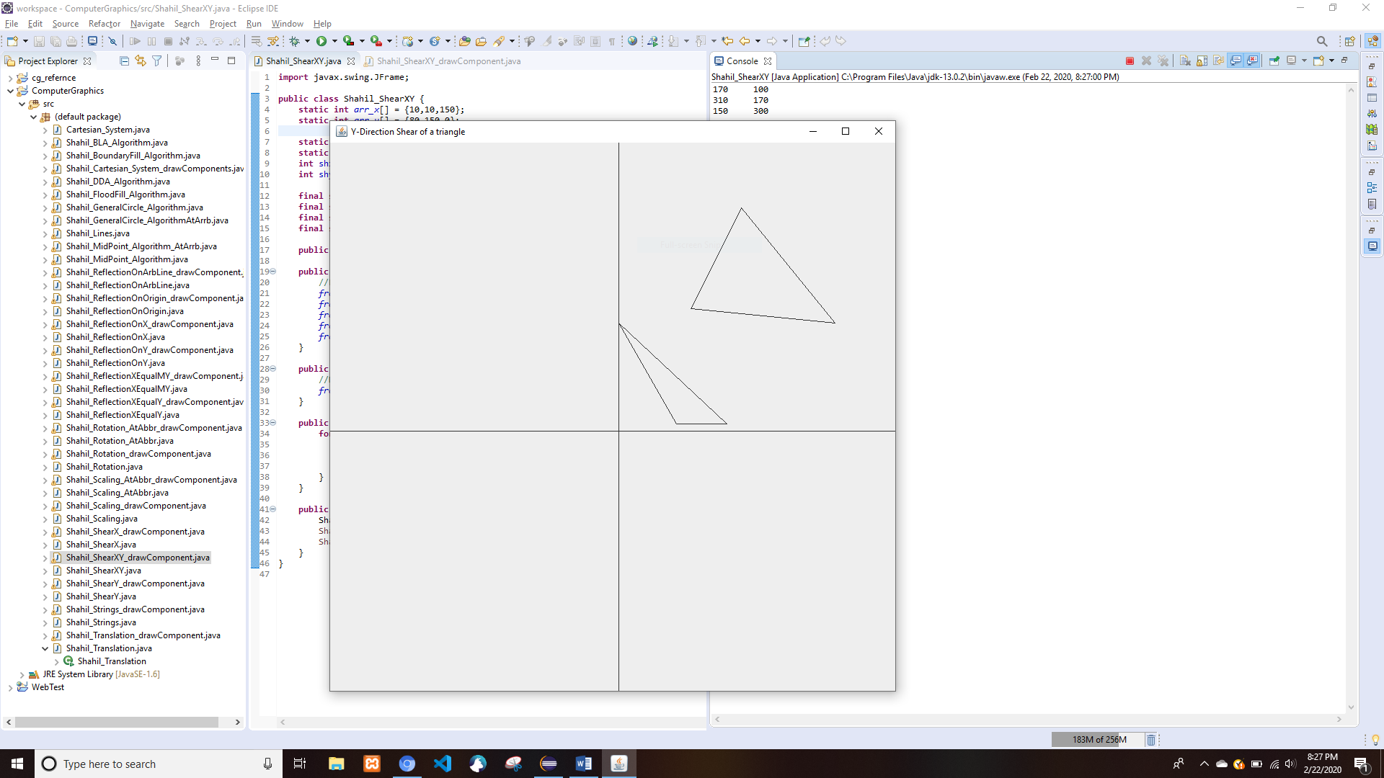

# Drawing Lines

* Shahil_Lines.java

**import** java.awt.BasicStroke;

**import** java.awt.Graphics;

**import** java.awt.Graphics2D;

**import** javax.swing.JComponent;

**import** javax.swing.JFrame;

**class** Shahil_MyCanvas **extends** JComponent {

**public** **void** paint(Graphics g) {

Graphics2D g2d = (Graphics2D) g;

**float**[] dash1 = { 2f, 0f, 2f };

g2d.drawLine(200, 300, 600, 300);

BasicStroke bs1 = **new** BasicStroke(1,

BasicStroke.***CAP_BUTT***,

BasicStroke.***JOIN_ROUND***,

1.0f,

dash1,

2f);

g2d.setStroke(bs1);

g2d.drawLine(200, 200, 600, 200);

BasicStroke bs2=**new** BasicStroke(30);

g2d.setStroke(bs2);

g2d.drawLine(200, 500, 600, 500);

}

}

**public** **class** Shahil_Lines {

**public** **static** **void** main(String[] args) {

JFrame frame = **new** JFrame();

frame.setDefaultCloseOperation(JFrame.***EXIT_ON_CLOSE***);

frame.setSize(800,800);

frame.getContentPane().add(**new** Shahil_MyCanvas());

frame.setVisible(**true**);

}

}

* Output

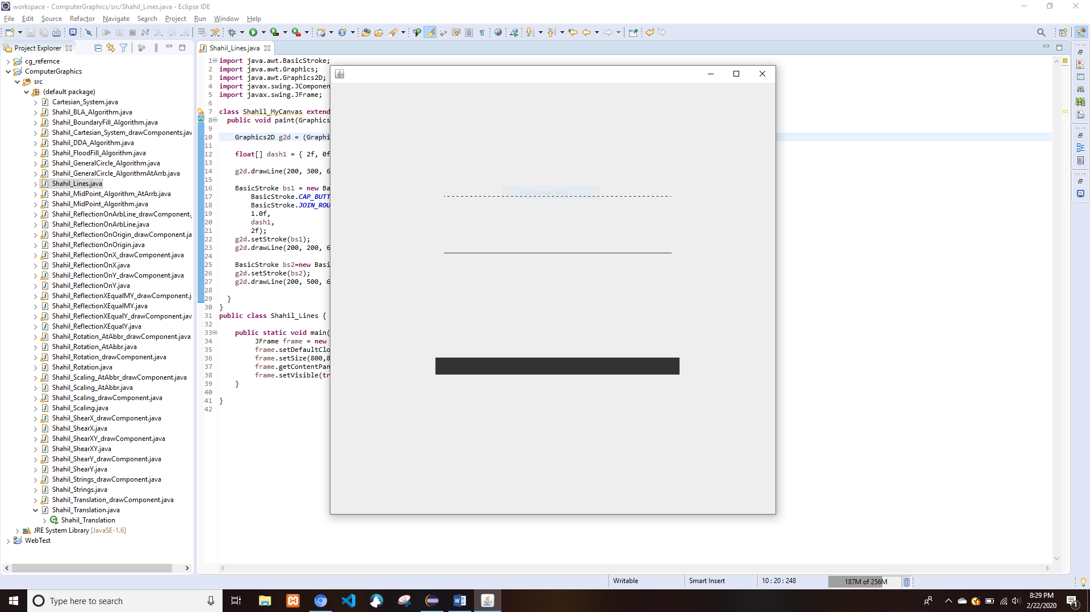

# Drawing Strings

* Shahil_Strings.java

**import** javax.swing.JFrame;

**public** **class** Shahil_Strings {

JFrame frame;

String str;

Shahil_Strings(){

//Frame making

frame = **new** JFrame();

frame.setTitle("Reflection On Origin");

frame.setSize(800,800);

frame.setVisible(**true**);

frame.setDefaultCloseOperation(JFrame.***EXIT_ON_CLOSE***);

}

**public** **void** Shahil_draw(){

//Drawing of axes

frame.add(**new** Shahil_Strings_drawComponent(str));

}

**public** **void** Shahil_Opertaion() {

str = "Report of Computer Graphics";

}

**public** **static** **void** main(String[] args) {

Shahil_Strings Shahil_obj = **new** Shahil_Strings();

Shahil_obj.Shahil_Opertaion();

Shahil_obj.Shahil_draw();

}

}

* Output

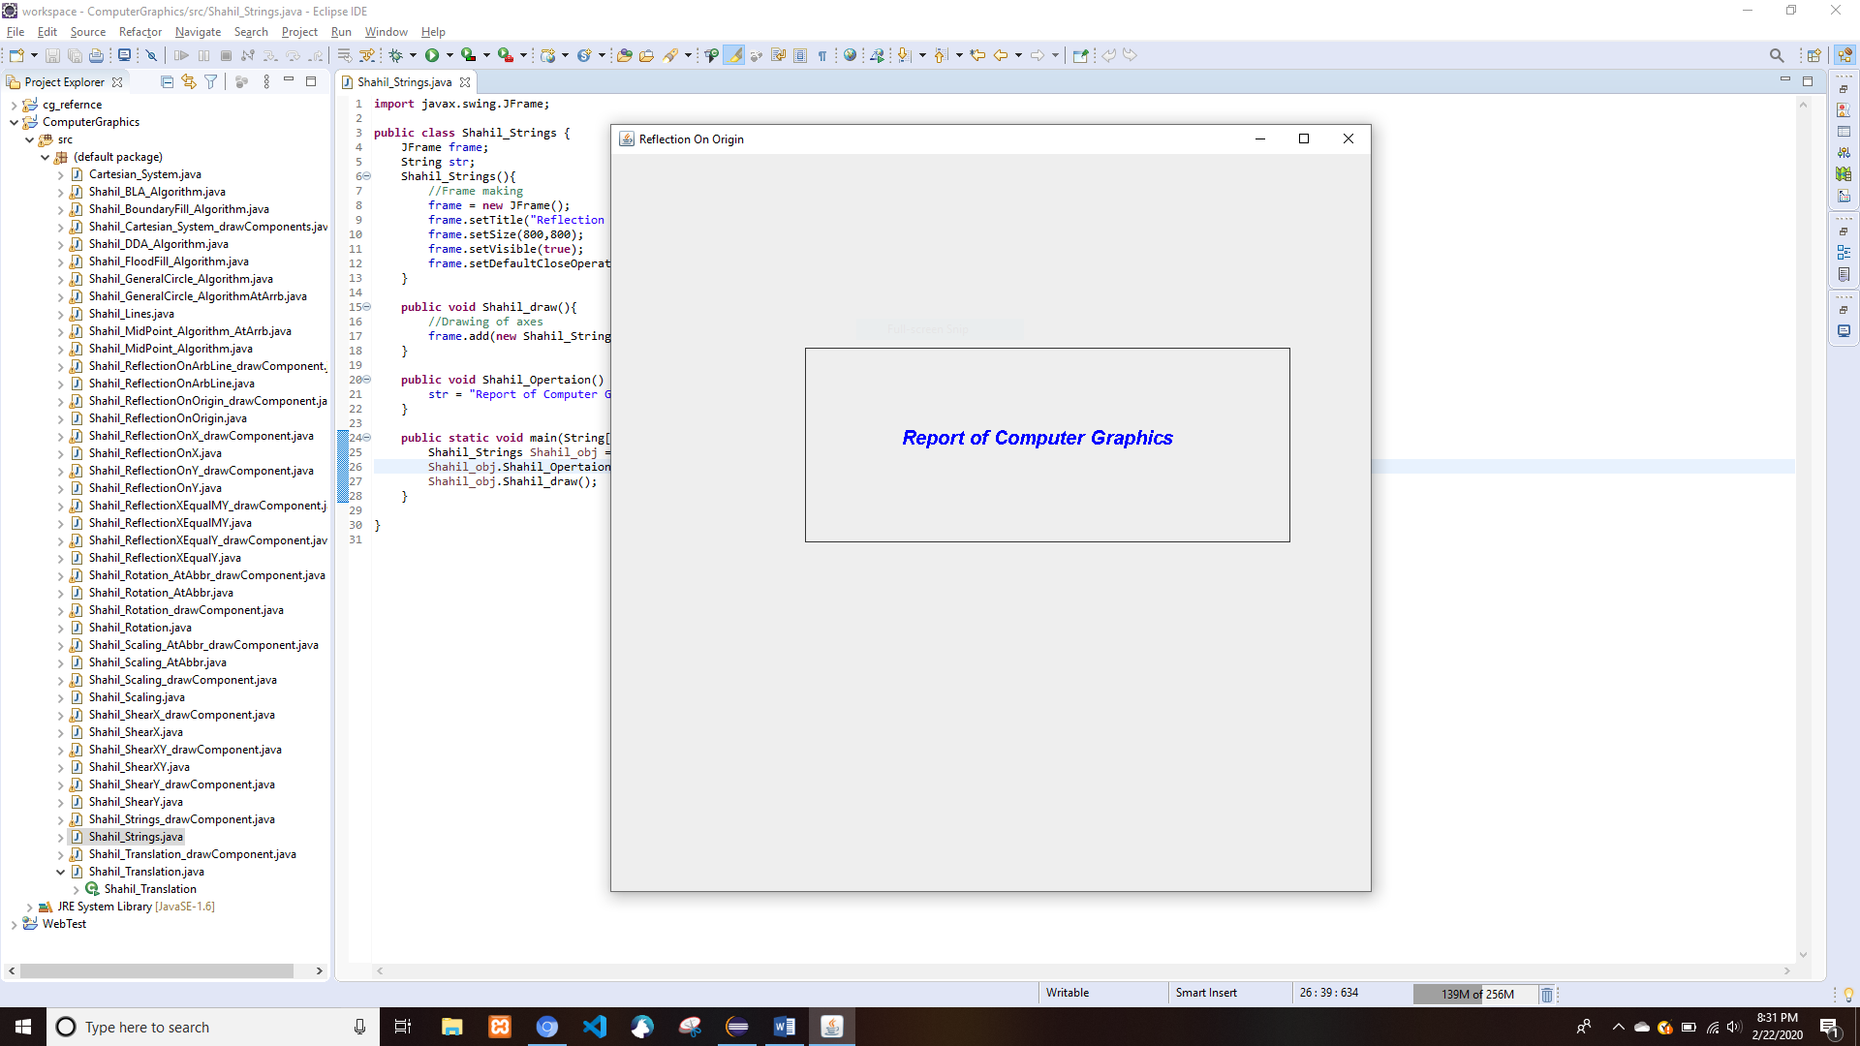

# Bresenham's Line Algorithm(BLA)

* Shahil_BLA_Algorithm.java

**import** java.awt.Graphics;

**import** java.awt.Graphics2D;

**import** javax.swing.JComponent;

**import** javax.swing.JFrame;

**class** Shahil_BLACanvas **extends** JComponent {

**int** x1,x2,y1,y2;

**int** a,b;

**int** dx,dy;//double Steps;

**int** x,y;//double xINC,yINC;

**int** p;

**public** **void** paint(Graphics g) {

Graphics2D g2d = (Graphics2D) g;

x1=100;

y1=400;

x2=700;

y2=400;

**if**(x2>x1)

a=1;

**else**

a=-1;

**if**(y2>y1)

b=1;

**else**

b=-1;

dx=Math.*abs*(x2-x1);

dy=Math.*abs*(y2-y1);

x=x1;

y=y1;

**if**(dx>dy){

p=((2*dy-dx));

g.fillOval(x,y,2,2);

**for**(**int** i=0;i<dx;i++){

**if**(p<=0){

x=x+a;

y=y;

p= (p+2*dy);

}**else**{

x=x+a;

y=y+b;

p=(p+2*dy-2*dx);

}

g.fillOval(x,y,2,2);

}

}

**else**{

p=((2*dx-dy));

g.fillOval(x, y, 2, 2);

**for**(**int** i=1;i<=dy;i++){

**if**(p<=0){

x=x;

y=y+b;

p= (p+2*dx);

}**else**{

x=x+a;

y=y+b;

p= (p+2*dx-2*dy);

}

g.fillOval(x, y, 2, 2);

}

}

}

}

**public** **class** Shahil_BLA_Algorithm {

**public** **static** **void** main(String[] args) {

JFrame frame = **new** JFrame();

frame.setDefaultCloseOperation(JFrame.***EXIT_ON_CLOSE***);

frame.setSize(800,800);

frame.getContentPane().add(**new** Shahil_BLACanvas());

frame.setVisible(**true**);

frame.setTitle("BLA Algorithm");

}

}

* Output

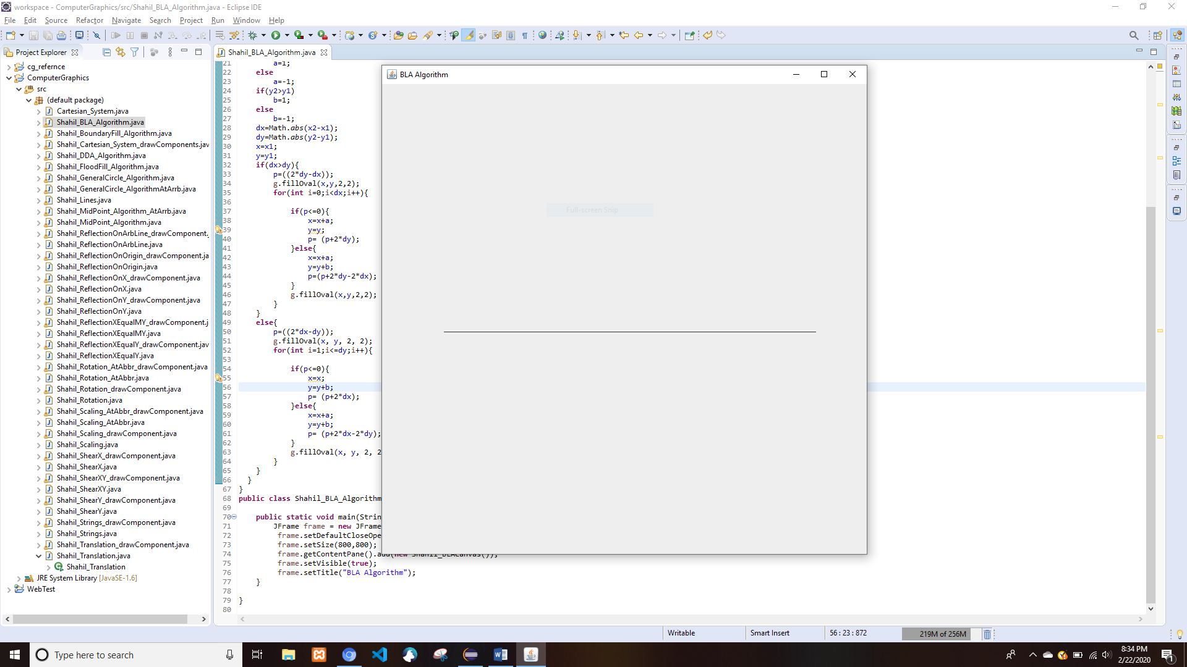

# Digital Differential Analyzer (DDA) Algorithm

* Shahil_DDA_Algorithm.java

**import** java.awt.BasicStroke;

**import** java.awt.Graphics;

**import** java.awt.Graphics2D;

**import** javax.swing.JComponent;

**import** javax.swing.JFrame;

**class** Shahil_DDACanvas **extends** JComponent {

**int** x1,x2,y1,y2;

**double** Steps;

**double** dx,dy;

**double** xINC,yINC;

**double** x,y;

**int** xx,yy;

**public** **void** paint(Graphics g) {

Graphics2D g2d = (Graphics2D) g;

x1=100;

y1=400;

x2=700;

y2=400;

//DX VALUES

dx=x2-x1;

dy=y2-y1;

//CHECK

**if**(Math.*abs*(dx)>Math.*abs*(dy)){

Steps=Math.*abs*(dx);

}**else**{

Steps= Math.*abs*(dy);

}

xINC=dx/Steps;

yINC=dy/Steps;

x=x1;

y=y1;

System.***out***.println(Steps);

**for**(**int** i=0;i<Steps;i++){

x=x+xINC;

y=y+yINC;

xx=(**int**)Math.*round*(x);

yy=(**int**)Math.*round*(y);

System.***out***.println(x+" "+y);

g2d.fillOval(xx, yy, 2, 2);

}

}

}

**public** **class** Shahil_DDA_Algorithm {

**public** **static** **void** main(String[] args) {

JFrame frame = **new** JFrame();

frame.setDefaultCloseOperation(JFrame.***EXIT_ON_CLOSE***);

frame.setSize(800,800);

frame.getContentPane().add(**new** Shahil_DDACanvas());

frame.setVisible(**true**);

frame.setTitle("DDA Algorithm");

}

}

* Output

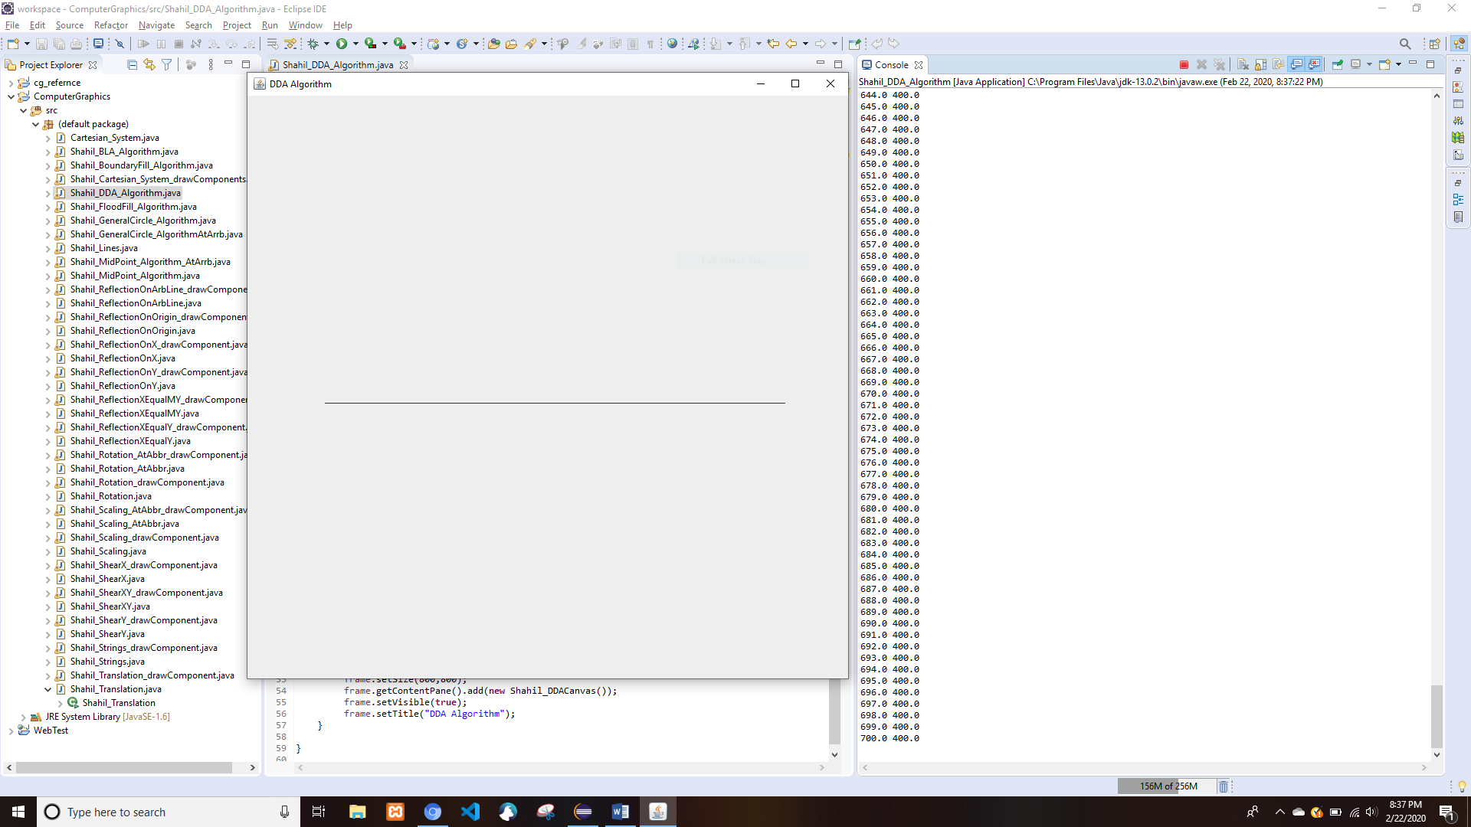

# General Circle Drawing Algorithm

## About Origin

* Shahil_GeneralCircle_Algorithm.java

**import** java.awt.Color;

**import** java.awt.Graphics;

**import** java.awt.Graphics2D;

**import** java.awt.geom.Line2D;

**import** java.awt.geom.Point2D;

**import** javax.swing.JComponent;

**import** javax.swing.JFrame;

**class** Shahil_GeneralCircleCanvas **extends** JComponent {

**public** **void** paint(Graphics g) {

Graphics2D g2d = (Graphics2D) g;

//Making the x and y axes

Line2D.Double x_line = **new** Line2D.Double(**new** Point2D.Double(0,400), **new** Point2D.Double(800,400));

Line2D.Double y_line = **new** Line2D.Double(**new** Point2D.Double(400, 0), **new** Point2D.Double(400, 800));

g2d.draw(x_line);

g2d.draw(y_line);

g2d.translate(400, 400);//translating to the middle

**int** xc,yc,r;

xc=0;

yc=0;

r=200;

**int** x=0;

**int** y=r;

**int** p=3-2*r;

**do** {

**if**(p<0)

p=p+4*x+6;

**else**{

p=p+4*(x-y)+10;

y=y-1;

}

x=x+1;

g2d.drawLine(xc+x,yc+y,xc+x,yc+y);

g2d.drawLine(x+xc,yc-y,xc+x,yc-y);

g2d.drawLine(xc-x,yc+y,xc-x,yc+y);

g2d.drawLine(xc-x,yc-y,xc-x,yc-y);

g2d.drawLine(xc+y,yc+x,xc+y,yc+x);

g2d.drawLine(xc+y,yc-x,xc+y,yc-x);

g2d.drawLine(xc-y,yc+x,xc-y,yc+x);

g2d.drawLine(xc-y,yc-x,xc-y,yc-x);

}**while**(x<y);

}

}

**public** **class** Shahil_GeneralCircle_Algorithm {

**public** **static** **void** main(String[] args) {

JFrame frame = **new** JFrame();

frame.setDefaultCloseOperation(JFrame.***EXIT_ON_CLOSE***);

frame.setSize(800,800);

frame.getContentPane().add(**new** Shahil_GeneralCircleCanvas());

frame.setVisible(**true**);

frame.setTitle("General Circle Drawing Algorithm");

}

}

* Output

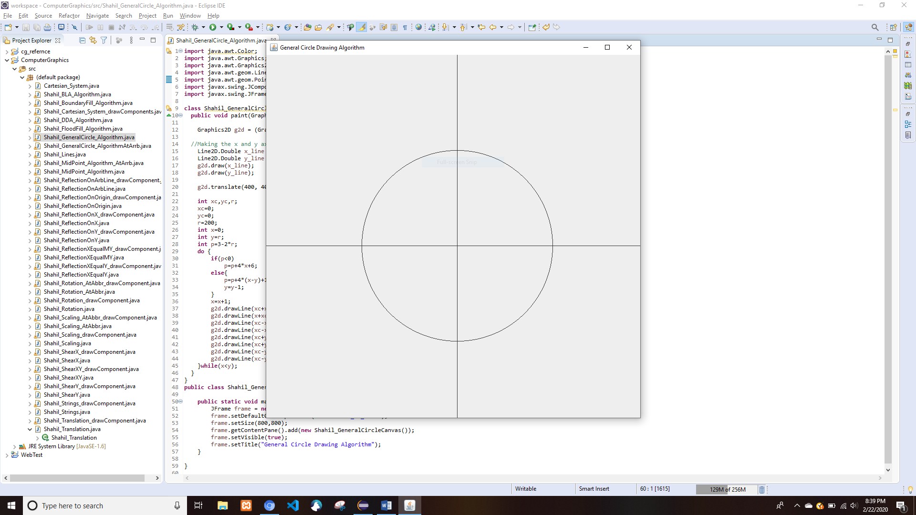

## At an Arbitrary Point

* Shahil_GeneralCircle_AlgorithmAtArrb.java

**import** java.awt.Graphics;

**import** java.awt.Graphics2D;

**import** java.awt.geom.Line2D;

**import** java.awt.geom.Point2D;

**import** javax.swing.JComponent;

**import** javax.swing.JFrame;

**class** Shahil_GeneralCircleCanvasAtArrb **extends** JComponent {

**public** **void** paint(Graphics g) {

Graphics2D g2d = (Graphics2D) g;

//Making the x and y axes

Line2D.Double x_line = **new** Line2D.Double(**new** Point2D.Double(0,400), **new** Point2D.Double(800,400));

Line2D.Double y_line = **new** Line2D.Double(**new** Point2D.Double(400, 0), **new** Point2D.Double(400, 800));

g2d.draw(x_line);

g2d.draw(y_line);

g2d.translate(400, 400);//translating to the middle

**int** xc,yc,r,h,k;

xc=0;

yc=0;

r=200;

**int** x=0;

**int** y=r;

h=50;//Arbitrary point x

k=50;//Arbitrary point y

**int** p=3-2*r;

**do** {

**if**(p<0)

p=p+4*x+6;

**else**{

p=p+4*(x-y)+10;

y=y-1;

}

x=x+1;

g2d.drawLine(xc+x+h,yc+y+k,xc+x+h,yc+y+k);

g2d.drawLine(x+xc+h,yc-y+k,xc+x+h,yc-y+k);

g2d.drawLine(xc-x+h,yc+y+k,xc-x+h,yc+y+k);

g2d.drawLine(xc-x+h,yc-y+k,xc-x+h,yc-y+k);

g2d.drawLine(xc+y+h,yc+x+k,xc+y+h,yc+x+k);

g2d.drawLine(xc+y+h,yc-x+k,xc+y+h,yc-x+k);

g2d.drawLine(xc-y+h,yc+x+k,xc-y+h,yc+x+k);

g2d.drawLine(xc-y+h,yc-x+k,xc-y+h,yc-x+k);

}**while**(x<y);

}

}

**public** **class** Shahil_GeneralCircle_AlgorithmAtArrb {

**public** **static** **void** main(String[] args) {

JFrame frame = **new** JFrame();

frame.setDefaultCloseOperation(JFrame.***EXIT_ON_CLOSE***);

frame.setSize(800,800);

frame.getContentPane().add(**new** Shahil_GeneralCircleCanvasAtArrb());

frame.setVisible(**true**);

frame.setTitle("General Circle Drawing Algorithm At Arbitrary Point");

}

}

* Output

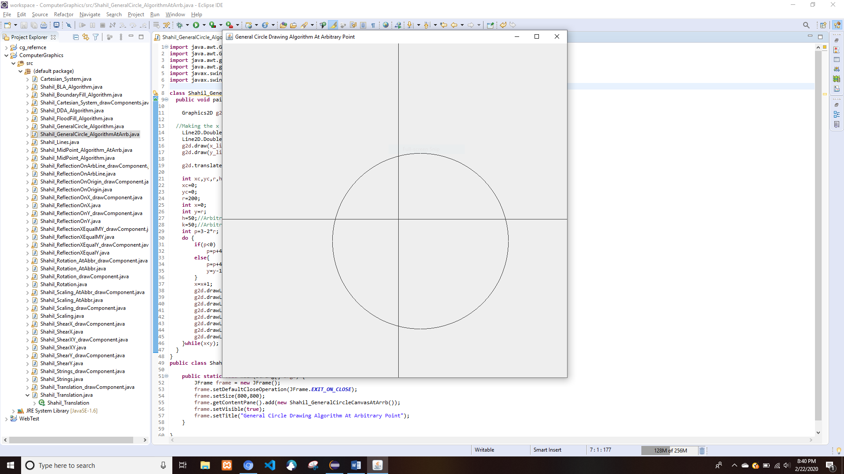

# Mid-Point Circle Drawing Algorithm

## About Origin

* Shahil_MidPoint_Algorithm.java

**import** java.awt.Color;

**import** java.awt.Graphics;

**import** java.awt.Graphics2D;

**import** java.awt.geom.Line2D;

**import** java.awt.geom.Point2D;

**import** javax.swing.JComponent;

**import** javax.swing.JFrame;

**class** Shahil_MidPointCanvas **extends** JComponent {

**int** r,x,y,p;

**public** **void** paint(Graphics g) {

Graphics2D g2d = (Graphics2D) g;

//Making the x and y axes

Line2D.Double x_line = **new** Line2D.Double(**new** Point2D.Double(0,400), **new** Point2D.Double(800,400));

Line2D.Double y_line = **new** Line2D.Double(**new** Point2D.Double(400, 0), **new** Point2D.Double(400, 800));

g2d.draw(x_line);

g2d.draw(y_line);

g2d.translate(400, 400);//translating to the middle

r=200;//Radius of circle

x=0;

y=r;

p=1-r;

**while**(x<y){

g2d.setColor(Color.***BLACK***);

g2d.fillOval(x, y,1, 2);

g2d.fillOval(x, -y,1, 2);

g2d.fillOval(-x, -y,1, 2);

g2d.fillOval(-x, y,1, 2);

g2d.fillOval(y, x,1, 2);

g2d.fillOval(y, -x,1, 2);

g2d.fillOval(-y, x,1, 2);

g2d.fillOval(-y, -x,1, 2);

**if**(p<0){

x+=1;

p=p+2*x+1;

}**else**{

x+=1;

y-=1;

p=p+2*x-2*y+1;

}

}

}

}

**public** **class** Shahil_MidPoint_Algorithm {

**public** **static** **void** main(String[] args) {

JFrame frame = **new** JFrame();

frame.setDefaultCloseOperation(JFrame.***EXIT_ON_CLOSE***);

frame.setSize(800,800);

frame.getContentPane().add(**new** Shahil_MidPointCanvas());

frame.setVisible(**true**);

frame.setTitle("Mid Point Circle Drawing Algorithm");

}

}

* Output

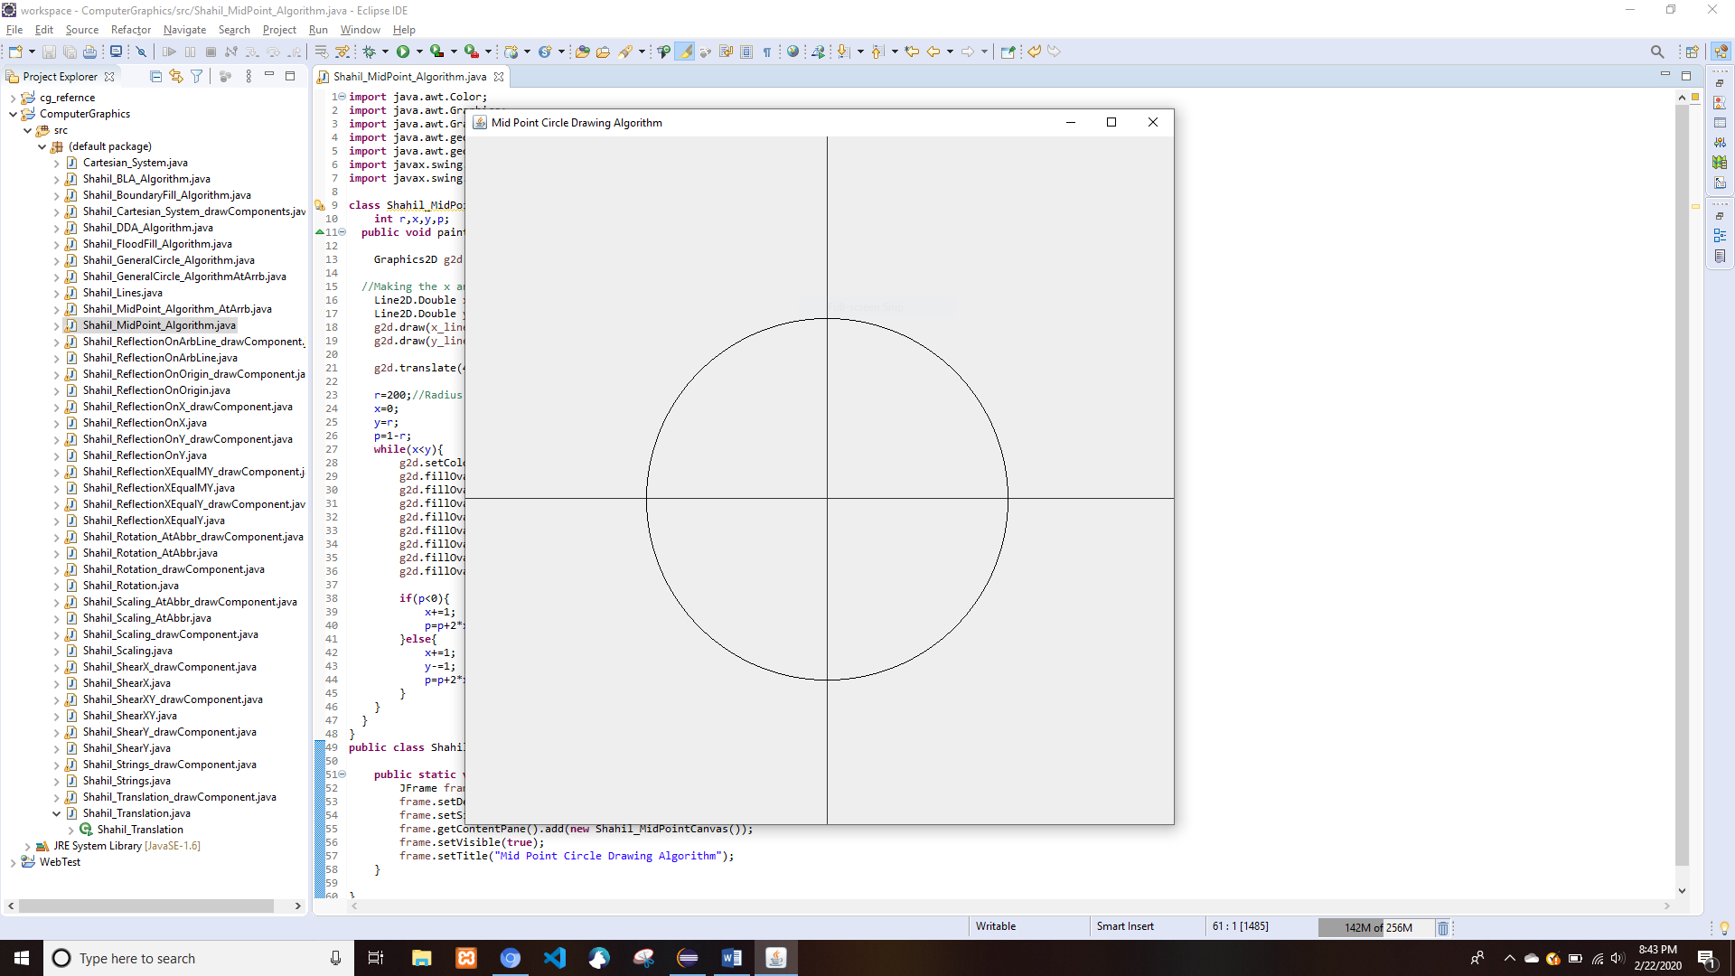

## About an Arbitrary Point

* Shahil_MidPoint_Algorithm_AtArrb.java

**import** java.awt.Color;

**import** java.awt.Graphics;

**import** java.awt.Graphics2D;

**import** java.awt.geom.Line2D;

**import** java.awt.geom.Point2D;

**import** javax.swing.JComponent;

**import** javax.swing.JFrame;

**class** Shahil_MidAtArrbPointCanvas **extends** JComponent {

**int** r,x,y,p,h,k;

**public** **void** paint(Graphics g) {

Graphics2D g2d = (Graphics2D) g;

//Making the x and y axes

Line2D.Double x_line = **new** Line2D.Double(**new** Point2D.Double(0,400), **new** Point2D.Double(800,400));

Line2D.Double y_line = **new** Line2D.Double(**new** Point2D.Double(400, 0), **new** Point2D.Double(400, 800));

g2d.draw(x_line);

g2d.draw(y_line);

g2d.translate(400, 400);//translating to the middle

r=200;//Radius of circle

x=0;

h=50;//Arbitrary point x

k=50;//Arbitrary point y

y=r;

p=1-r;

**while**(x<y){

g2d.setColor(Color.***BLACK***);

g2d.fillOval(x+h, y+k,1, 2);

g2d.fillOval(x+h, -y+k,1, 2);

g2d.fillOval(-x+h, -y+k,1, 2);

g2d.fillOval(-x+h, y+k,1, 2);

g2d.fillOval(y+h, x+k,1, 2);

g2d.fillOval(y+h, -x+k,1, 2);

g2d.fillOval(-y+h, x+k,1, 2);

g2d.fillOval(-y+h, -x+k,1, 2);

**if**(p<0){

x+=1;

p=p+2*x+1;

}**else**{

x+=1;

y-=1;

p=p+2*x-2*y+1;

}

}

}

}

**public** **class** Shahil_MidPoint_Algorithm_AtArrb {

**public** **static** **void** main(String[] args) {

JFrame frame = **new** JFrame();

frame.setDefaultCloseOperation(JFrame.***EXIT_ON_CLOSE***);

frame.setSize(800,800);

frame.getContentPane().add(**new** Shahil_MidAtArrbPointCanvas());

frame.setVisible(**true**);

frame.setTitle("Mid Point Circle Drawing Algorithm At Arbitrary Point");

}

}

* Output

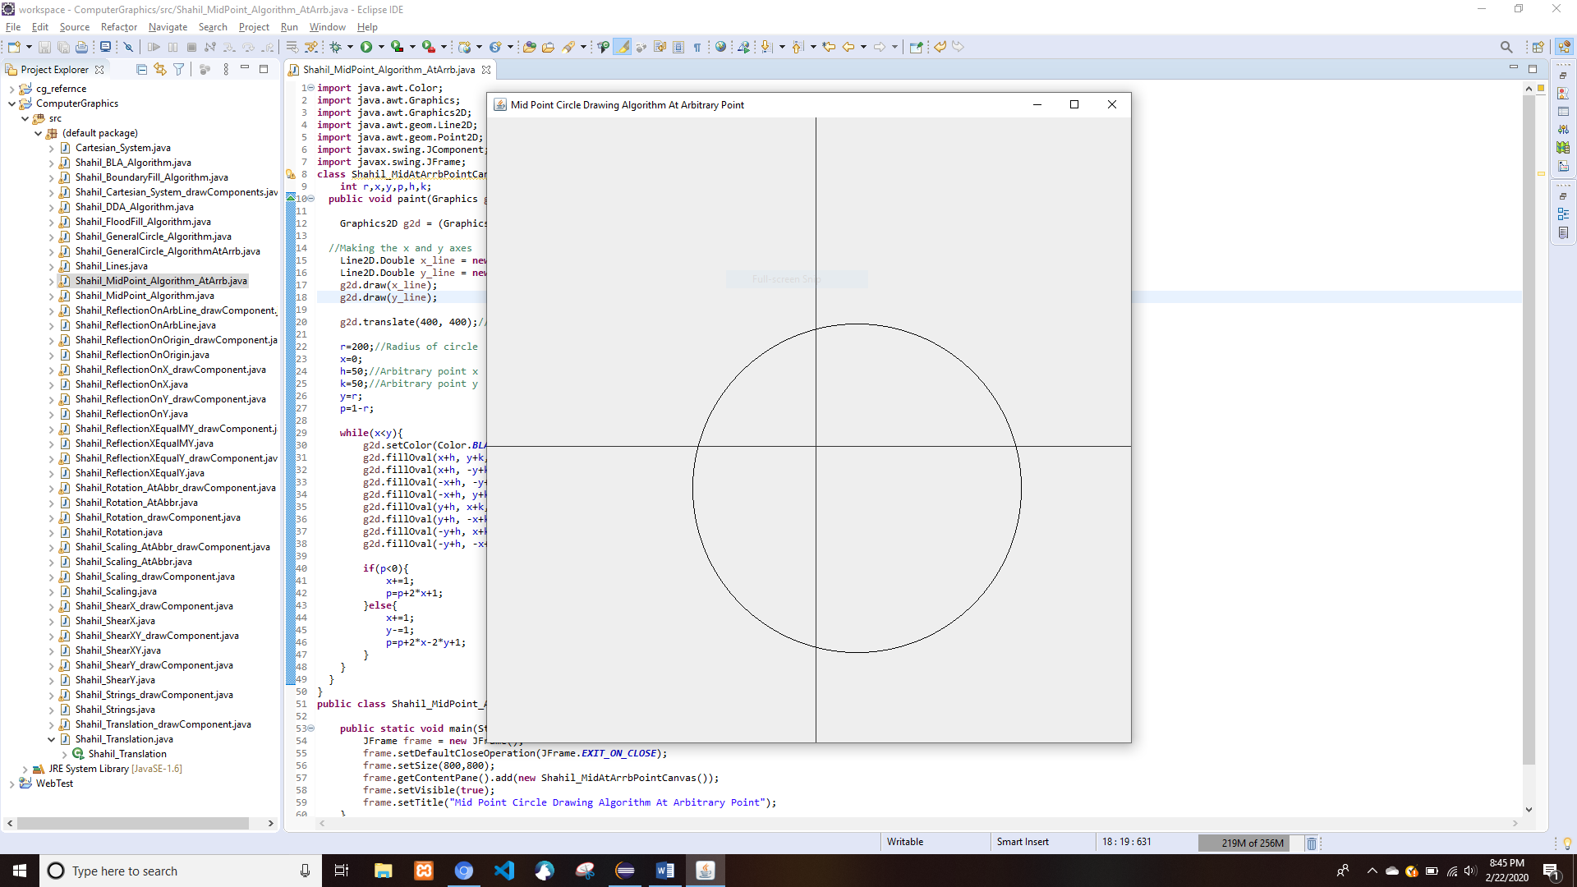

# Boundary Fill Algorithm

* Shahil_BoundaryFill_Algorithm.java

**import** java.awt.Color;

**import** java.awt.Dimension;

**import** java.awt.Graphics;

**import** java.awt.Graphics2D;

**import** java.awt.event.MouseAdapter;

**import** java.awt.event.MouseEvent;

**import** java.awt.image.BufferedImage;

**import** javax.swing.JFrame;

**import** javax.swing.JPanel;

**public** **class** Shahil_BoundaryFill_Algorithm **extends** JPanel{

**final** **int** boundaryColor = Color.***RED***.getRGB();

**final** **int** fillColor = Color.***GREEN***.getRGB();

BufferedImage img;

Graphics2D g2;

Shahil_BoundaryFill_Algorithm(){

img = **new** BufferedImage(800,800,BufferedImage.***TYPE_INT_RGB***);

setPreferredSize(**new** Dimension(800,800));

setMinimumSize(getPreferredSize());

g2 = img.createGraphics();

g2.setColor(Color.***green***);

g2.clearRect(0, 0, 800, 800);

g2.drawRect(350 , 300, 100, 100);

addMouseListener(**new** MouseAdapter() {

**public** **void** mouseClicked(MouseEvent e) {

System.***out***.println(e.getX()+" "+e.getY());

boundFill(e.getX(), e.getY(), img.getRGB(e.getX(), e.getY()));

}

});

}

**public** **void** paintComponent(Graphics g){

g.drawImage(img, 0, 0, **null**);

}

**public** **void** boundFill(**int** seedX,**int** seedY,**int** rgb)

{

**if**(img.getRGB(seedX, seedY)!=boundaryColor && img.getRGB(seedX, seedY)!=fillColor)

{

img.setRGB(seedX,seedY,fillColor);

update(getGraphics());

boundFill(seedX,seedY-1,rgb);

boundFill(seedX,seedY+1,rgb);

boundFill(seedX-1,seedY,rgb);

boundFill(seedX+1,seedY,rgb);

}

}

**public** **static** **void** main(String args[]){

JFrame f = **new** JFrame("Boundary fill algorithm");

f.setVisible(**true**);

f.setDefaultCloseOperation(JFrame.***EXIT_ON_CLOSE***);

Shahil_BoundaryFill_Algorithm fill = **new** Shahil_BoundaryFill_Algorithm();

f.add(fill);

f.pack();

}

}

* Output

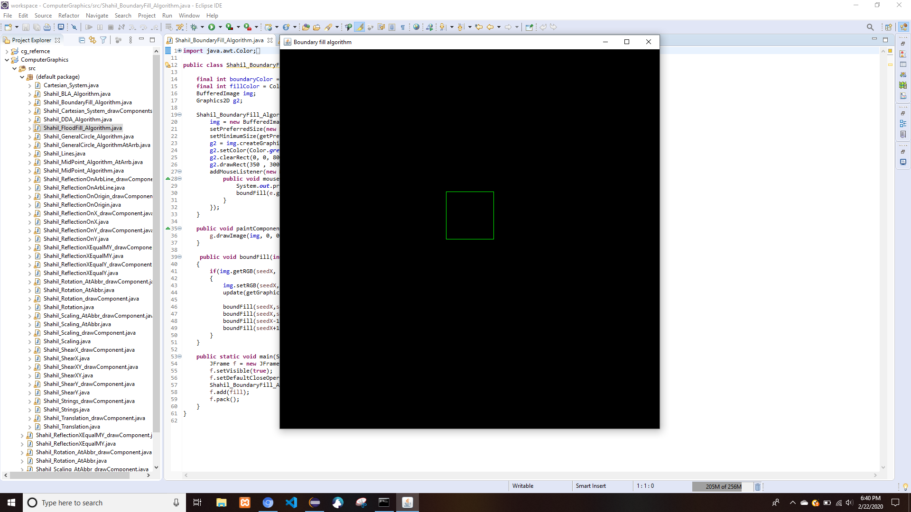

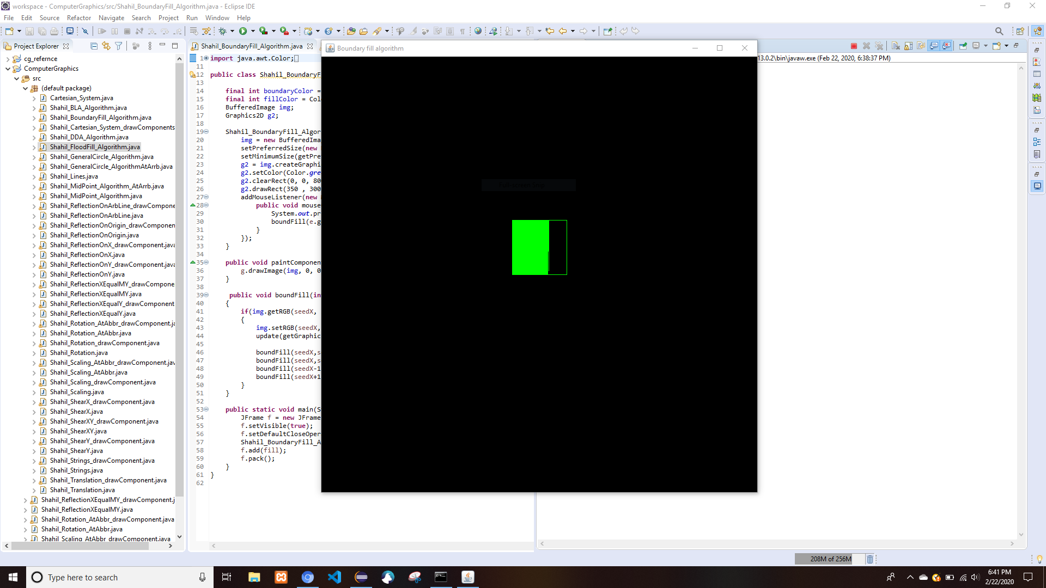

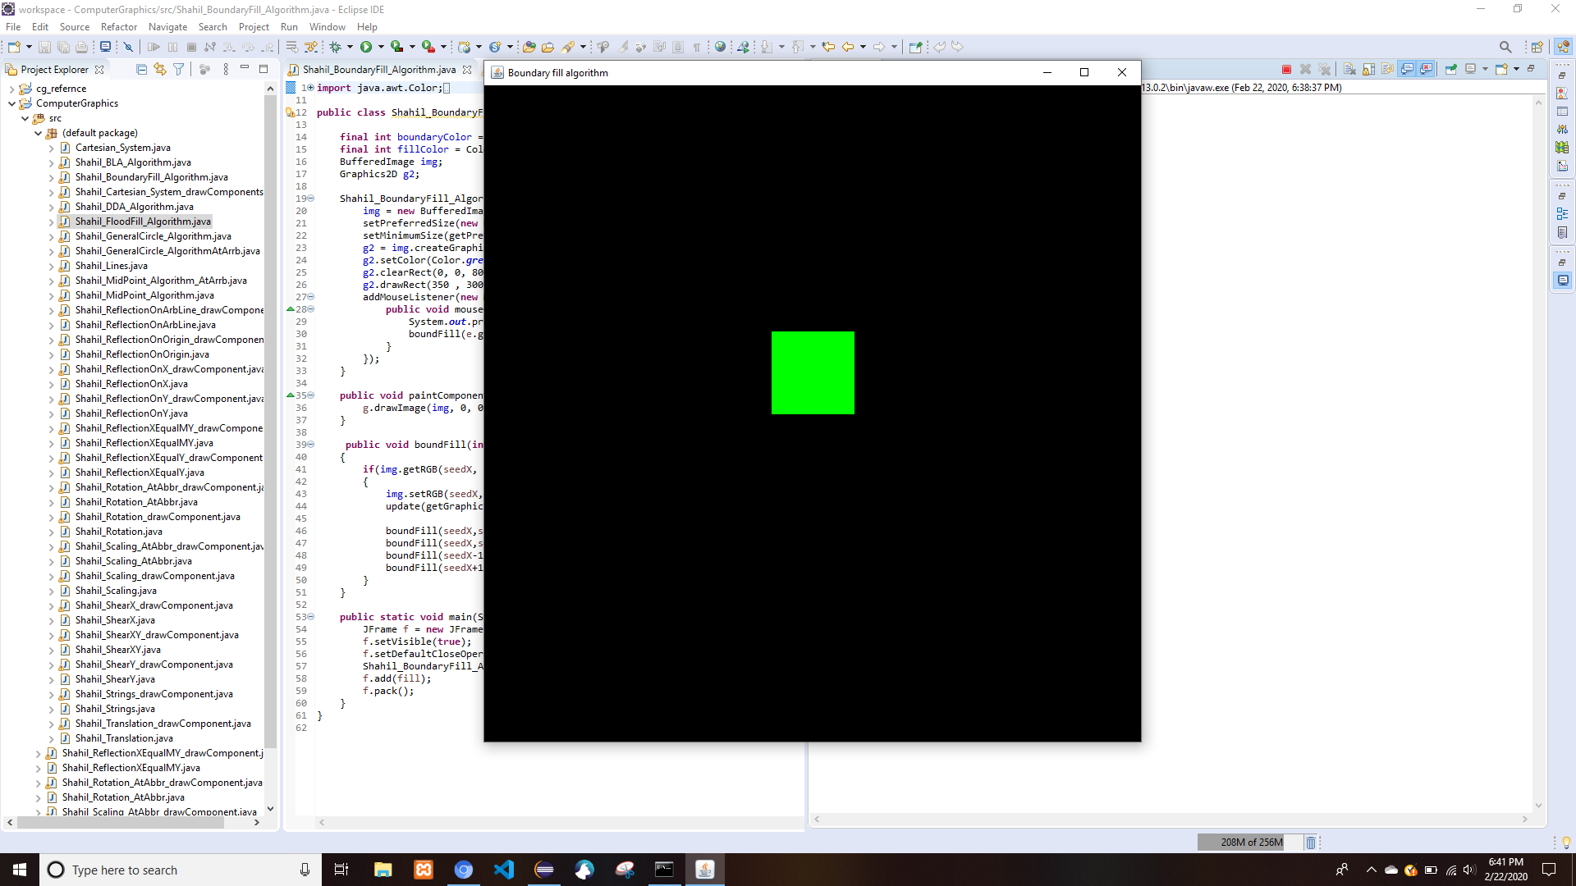

# Flood Fill Algorithm

* Shahil_FloodFill_Algorithm.java

**import** java.awt.Color;

**import** java.awt.Dimension;

**import** java.awt.Graphics;

**import** java.awt.Graphics2D;

**import** java.awt.event.MouseAdapter;

**import** java.awt.event.MouseEvent;

**import** java.awt.image.BufferedImage;

**import** javax.swing.JFrame;

**import** javax.swing.JPanel;

**public** **class** Shahil_FloodFill_Algorithm **extends** JPanel{

**final** **int** targetColor = Color.***BLUE***.getRGB();

BufferedImage img;

Graphics2D g2;

Shahil_FloodFill_Algorithm(){

img = **new** BufferedImage(800,800,BufferedImage.***TYPE_INT_RGB***);

setPreferredSize(**new** Dimension(800,800));

setMinimumSize(getPreferredSize());

g2 = img.createGraphics();

g2.setBackground(Color.***WHITE***);

g2.setColor(Color.***blue***);

g2.clearRect(0, 0, 800, 800);

g2.setColor(Color.***BLUE***);

g2.fillRect(350 , 300, 100, 100);

g2.setColor(Color.***GREEN***);

g2.fillRect(375 , 325, 50, 50);

addMouseListener(**new** MouseAdapter() {

**public** **void** mouseClicked(MouseEvent e) {

floodFill(e.getX(), e.getY(), img.getRGB(e.getX(), e.getY()));

}

});

}

**public** **void** paintComponent(Graphics g){

g.drawImage(img, 0, 0, **null**);

}

**public** **void** floodFill(**int** seedX,**int** seedY,**int** rgb)

{

**if**(img.getRGB(seedX, seedY)==targetColor)

{

img.setRGB(seedX,seedY,Color.***red***.getRGB());

update(getGraphics());

floodFill(seedX,seedY-1,rgb);

floodFill(seedX,seedY+1,rgb);

floodFill(seedX-1,seedY,rgb);

floodFill(seedX+1,seedY,rgb);

}

}

**public** **static** **void** main(String args[]){

JFrame f = **new** JFrame("Flood fill algorithm");

f.setVisible(**true**);

f.setDefaultCloseOperation(JFrame.***EXIT_ON_CLOSE***);

Shahil_FloodFill_Algorithm fill = **new** Shahil_FloodFill_Algorithm();

f.add(fill);

f.pack();

}

}

